

|  |
| --- |
| **Working with Bloomberg**  **at FI PD**  **A Beginners Guide** |

**Robert Hennings**

**FI ETD PD**

**October 2022**

Contents

Introduction 2

Section 1: Getting started 4

Section 2: Basic Navigation 7

Excurse: Bloomberg-Tickers of Future products 10

What are generics in Bloomberg? 11

Specific contract Tickers for Futures and Options 11

Section 3: Most important mnemonics 11

General analysis 11

Currencies 12

Derivatives 12

Economics 12

Excel Tools 12

Equities 12

Fixed Income 12

News 13

Additional resources 13

Section 4: Mnemonics in detail 13

DES – description page 13

BI – Bloomberg intelligence dashboards 14

FXC – Currency Matrix Performance 17

OMON – Options Monitor 18

FED – Federal reserve Analysis 19

ECO – Economics calendar 20

XLTP – Excel Template Library provided by Bloomberg 21

FLDS – Fields 22

SRCH – Search 24

WB – World Bond Markets 25

CRVF – Curve Finder 25

TOP – Top News 26

MSG – Messages/Emails 27

GRAB – Send screenshots 28

Section 5: The Excel Add-In, Formula Syntax and Data Types 30

The Excel Add-In 30

The Spreadsheet Builder 31

The Function Builder 36

BDP 36

BDH 37

BDS 37

The BQL Builder 37

Section 6: Case studies 45

Getting Volume Data for Future Products 45

Getting Volume Data for Options (on Futures) 53

Getting Open Interest Data for Future Products 54

Getting Open Interest Data for Options (on Futures) 54

Getting Volatility Data for Future Products 54

Getting Volatility Data for Options (on Futures) 54

Search for competitor products from other exchanges and get their data 54

Section 7: BMC – Bloomberg Market Concepts 57

Section 8: Getting help 58

# Introduction

This piece is aimed at new interns, working students or full members of the fixed income Exchange traded derivatives Product Development Team. As new joiners come from diverse backgrounds in Finance, Business, Mathematics, IT etc., this document will go through all the basic topics regarding work with Bloomberg. The sections will be accompanied by exercises, which you’ll be expected to finish within your first 2 weeks of employment. The necessary tools will be Excel and Bloomberg.

First we will go through some Basics on how to set up a new account in the terminal, look at basic navigation and cover some functions in more detail. We will provide more information especially on how to load data, the data types in Bloomberg and the Excel-Add In. Following we will highlight some of the most used functions of the Terminal we use at the PD department in combination with some accompanying case studies for the reader as exercises.

# Section 1: Getting started

In this section we will look at the first steps to set up a Bloomberg Account.

An extensive more general guide can be found here: <https://data.bloomberglp.com/professional/sites/10/Getting-Started-Guide-for-Students-English.pdf>

First find the application by searching for its name: “Bloomberg” or click on the icon:



Figure 1: Bloomberg Application Icon

After a short while the Starting screen will appear:

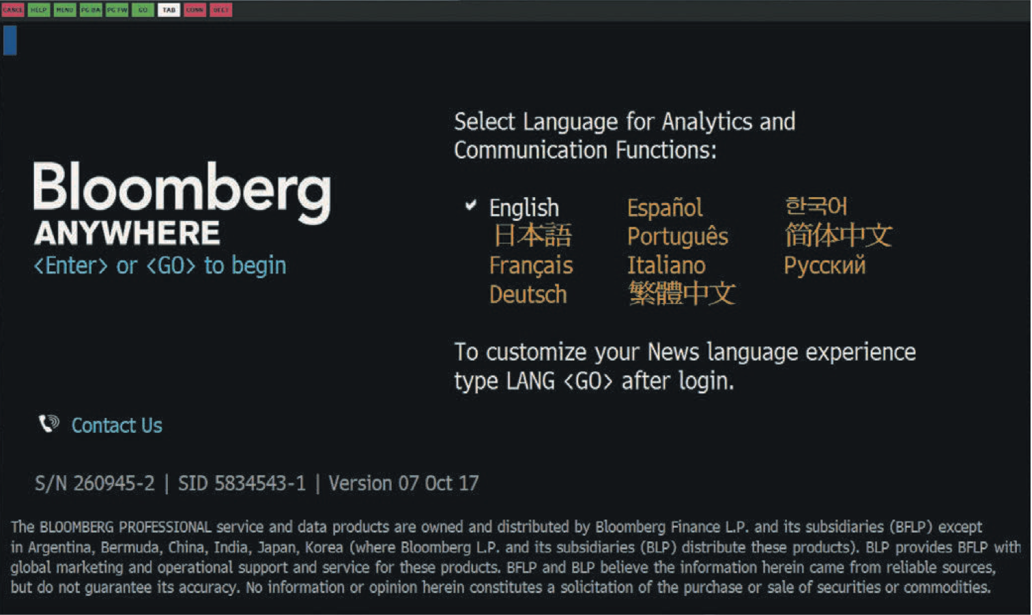

Figure 2: Starting Screen

Select your language and click on enter or the <GO> area.

Next, this screen will appear, asking for your login credentials. If it is your first time accessing the terminal you have to set up a new account by clicking on “Create New Login”:

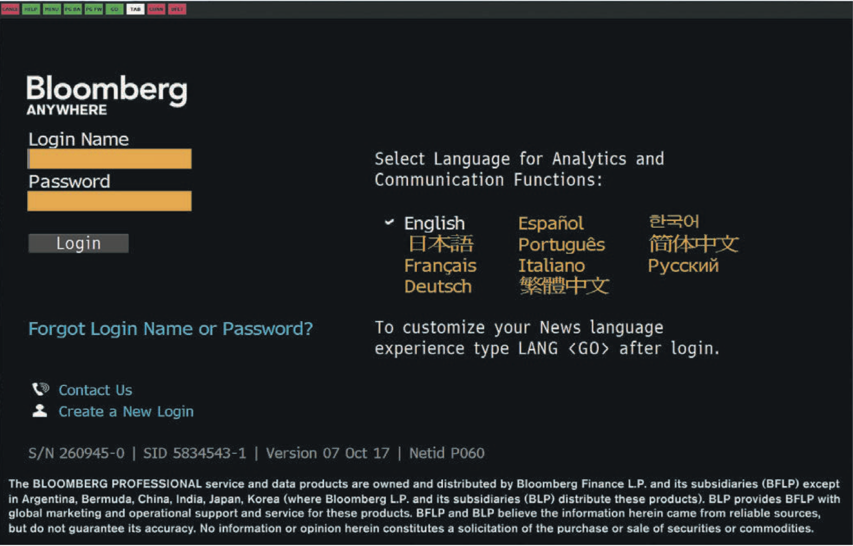

Figure 3: Create a New Account

After that you will be guided through the set up process. In the mobile-field, where they ask you to put in a mobile-number either put in your private phone number or the one from your corporate-device. Email of course your corporate Email. Make sure to remember your login credentials.

**One immediate observable constant in the Bloomberg Terminal will appear: everything highlighted in the iconic orange is a field that you can click on for further options or you have to provide input/change the current input. That’s a point you should keep in mind as some Terminal pages can be quite messy and full of content that can be disturbing.**

The starting screen will show up where you immediately see a certain GUI-structure:

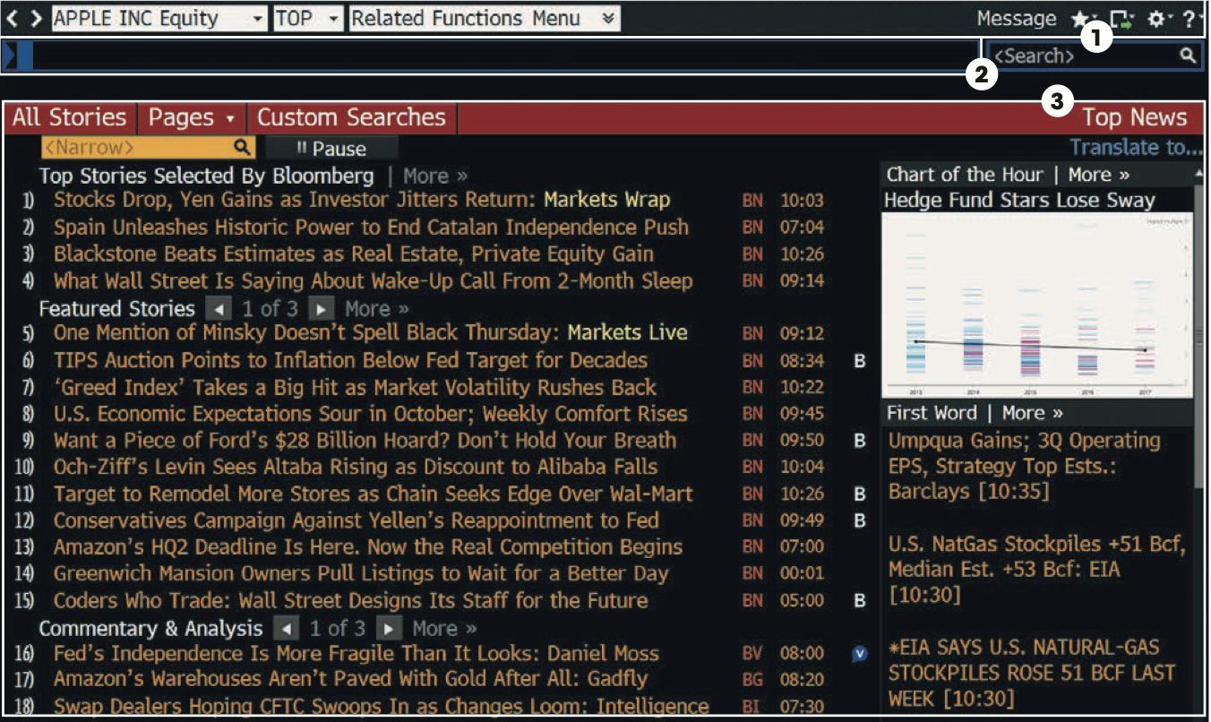

Figure 4: Bloomberg-Starting Page after Login

You have three main areas per open tab. In general, the Terminal Application is organized like a Browser with single tabs to open and windows to drag and drop. You can open new tabs with the keyboard shortcut: STRG + T just like in any browser.

**1.** **Toolbar** — The left side of the toolbar includes the menu tab and a drop-down list of recently loaded securities, with the current loaded security visible. The right side features icons to help you perform key tasks, including exporting data, viewing favorite places and securities, accessing Help and adjusting your defaults and display.

**2.** **Command line** — Here you enter commands for functions and securities. You can also perform a keyword search for securities and functions from the command line. This Autocomplete feature makes the Bloomberg Terminal entirely discoverable from the command line. From any screen that is currently open you can immediately type in words in the command line.

**3.** **Function area** — Here you will see the actual function content displayed. Often you will find Buttons named “Export” where you have options to export currently seen data. We will touch on that later again.

The most important step is to find the needed Bloomberg-Ticker for the security you want to analyze, as it is the key component for accessing functions you can perform on the security. As maybe intuitively thought, the functions you can apply on securities differ based on the broad asset class the security falls in. So we will mainly cover functions for Derivatives (Futures, Options, Swaps) and Fixed Income securities.

# Section 2: Basic Navigation

In this section we cover the basic structures of the tab organized GUI of the terminal. Use STRG + T to open new tabs and the END or DELETE button of your keyboard to return to the last open screen in your tab just like a reverse click in a browser tab brings you back one page.

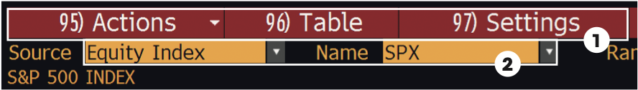

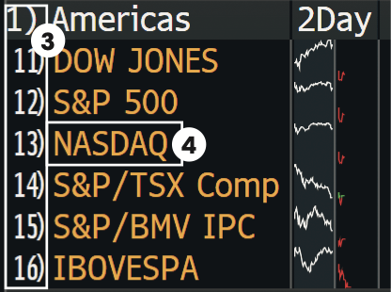

Figure 5: Basic structures of Tabs in the Terminal

1. Menu bar
2. Orange fields
3. Number <GO>
4. Clickable area

**Menu bar**

The red bar at the top of each function includes the function’s title at the right and provides drop-down menus and buttons to help you perform key tasks. It may also contain a page number indicator.

**Orange fields**

Orange fields indicate areas on the screen that you can change. Orange-colored fields represent editable-form elements, text and data input areas and drop-down lists.

**Clickable areas**

Moving your cursor over a clickable area of the screen shows one of three types of indicators:

• **White outline box —** Indicates most clickable items, including entries in lists, menus and tables.

• **Numbered information —** Numbers indicate a topical link, enabling quick access to a related page by either clicking the line or entering the number and clicking <GO>.

• **Highlighting —** Indicates clickable buttons and tabs. **Keyboard navigation**

Typing in the number next to an option allows you to quickly navigate within the function using only your keyboard. Many clickable onscreen options are labeled with a Number <GO>.

As one can see from Figure 6 when you click on the “Related Functions Menu” button, depending on the asset class the security belongs to, we have different functions for analysis we can apply. These functions have so called **mnemonics (shortcuts)** to type in after the Security specific Bloomberg-Ticker. So, we have a general structure we can remember to guide us through the whole terminal:

**<Security specific BL-Ticker> <Asset class> <Function mnemonic>**

As we are mainly concerned about Derivatives (Futures, Options, Swaps) our Asset class component is in general **“Comdty” for Commodity**. The general asset classes that is being differenced between can found on the Bloomberg Terminal keyboard. If you want to save some time you can just hit one of the buttons (the Comdty button e.g.) instead of typing in every time the asset class names by hand.

The security specific Bloomberg-Tickers can be found in three main ways:

1. Type in the security’s name in the (blue) command line and rely on the Bloomberg autocomplete, e.g. type in “Euro Bund Future” and see what Bloomberg recommends as best fit, click on the best fitting option from the list that is provided. Look at the description page (**DES**) to validate your choice. Get the Bloomberg-Ticker.

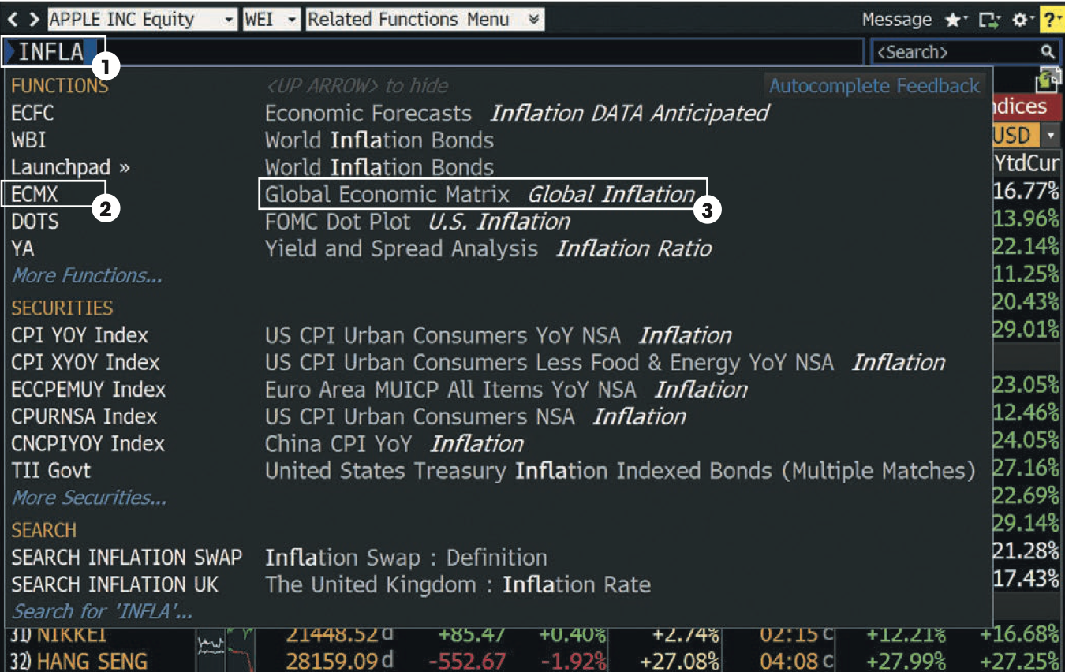

Figure 6: Bloomberg-Recommendations for keyword search.

Here you can see the recommendations Bloomberg provides you with for the entered term Inflation.

If we click on the little field “Related functions menu” we see other applicable functions for analysis that can be a good basis if you search something or just want the last screen back you saw (click on the last used function). We will dive deeper in some of the seen functions of the screenshot later.

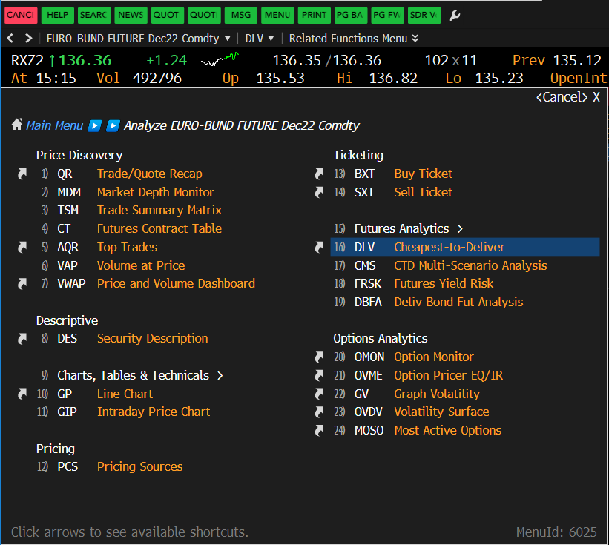

1. Look at the EUREX website and search for the product specific BL-Ticker, watch out for the provided BL-Tickers there, as they must not be the 100% correct ones all the time.

EUREX landing page of the interest rate derivatives: <https://www.eurex.com/ex-en/markets/int>

Go to a specific product: <https://www.eurex.com/ex-en/markets/int/fix/government-bonds>

(Euro Bund Future: <https://www.eurex.com/ex-en/markets/int/fix/government-bonds/Euro-Bund-Futures-137298>)

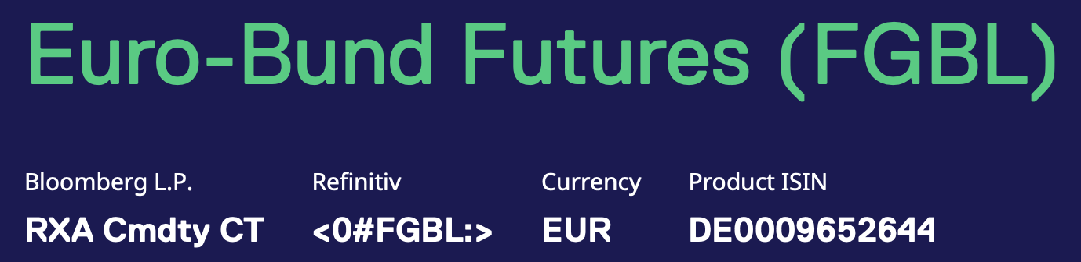

Figure 7: EUREX Website information for the Euro-Bund Future.

Here one can see that the BL-Ticker isn’t completely correct, we will analyze the tickers shortly in more detail.

1. Look at the Excel file that houses an overview of all the (for us) important EUREX products, categorized by product type (Futures, Options, FX). It can be found in the New Joiners folder, that you should be provided with.

File path:

H:\DBAG\FT\900 Work Areas\_General\NewJoiners\ProductsColourCodesLPs.xlsx.

## Excurse: Bloomberg-Tickers of Future products

The general structure that the BL-Ticker of a Future product follows is:

**<Specific Security Ticker – Component indicating which of the currently tradable contracts to choose> <Asset class> <Further mnemonics for analysis>**

Here the Specific Ticker is “RX” for the Bund Future, the component indicating which of the currently tradable contracts to choose, is here the “A” for the currently active contract. Remember we can trade currently the active contract (front month), the mid month (2nd expiry) and the back month (3rd expiry).

We can change the “A” in “RXA” to numbers: “RX1”, “RX2” or “RX3” to get the so called “Generic contracts”. As there are only three tradable contracts at once the numbers range only till 3.

### What are generics in Bloomberg?

As the front month contract is alive only a certain time we could run into inconveniences when we want to analyze longer time series of the front month. As we will later see it is always possible to extract the exact specific contract in each time slot but this is quite a hassle as the contract ticker comprises more variable components that can be hard to rebuild in excel. So Bloomberg provides a technique that chains all the front month contracts together so that one will obtain a long time series without missing values. This series is called “Generic” and is not only available for the front month (“1st Generic”) but also for the remaining contracts: “2nd Generic” and “3rd Generic”.

But if we want to analyze only a really specific contract we can also rebuild this time series by hand by providing some other syntax components, as we will shortly see below.

### Specific contract Tickers for Futures and Options

If we want to analyze a specific Futures contract we can do so by providing additional components of the Bloomberg syntax. This is also possible for Options contracts.

Assume we want to get data of the Sep22 Bund Future contract, and only of this specific time series, not the generics. We can rebuild the BL-Ticker of this contract:

**<Security specific BL-Ticker – Letter of the contract month – number or the contract year> <Asset class> <Function mnemonic>**

When one goes to the description page of the Euro Bund Future (**DES**) one will see that there is a little calendar and an area called contract table (**CT**). These areas are now of our interest. In the provided screenshot we just typed “RXA” in the command line and chose the suggested active Bund Future contract.

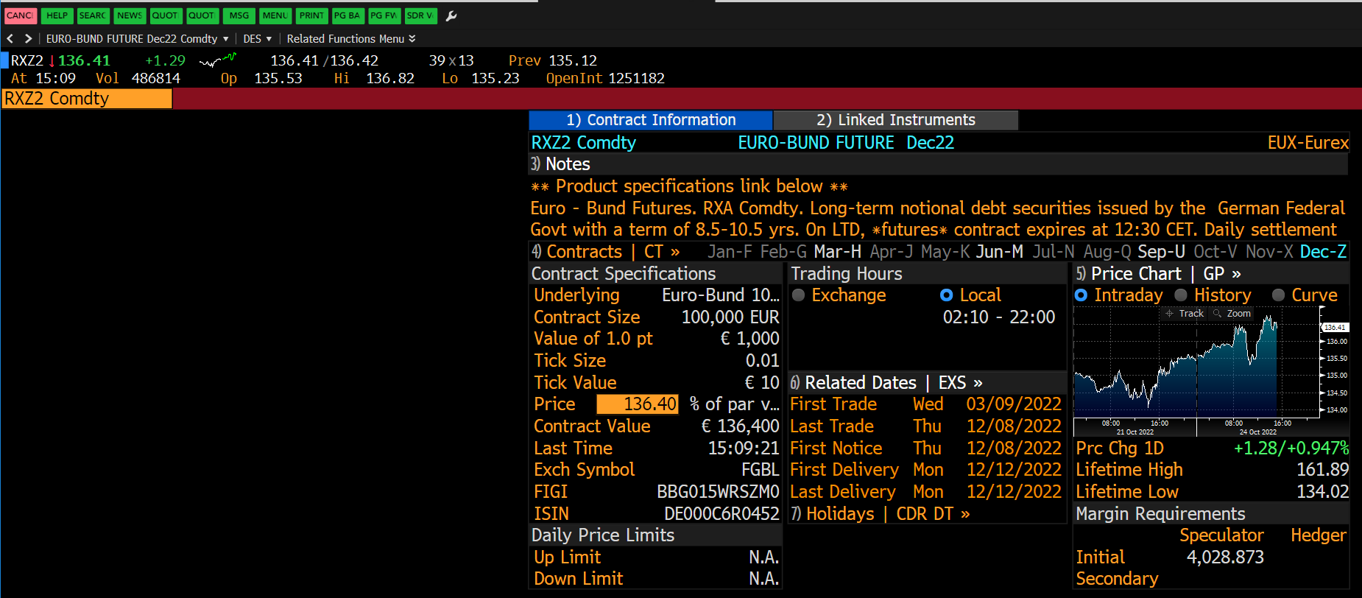

Tha actual contract is the Dec22 one and we can see its specific unique contract ticker already showing up. We also see a little calendar with the according abbreviations for the months. The March (H), June (M), September (U) and the December are highlighted as for the Bund Future the expiry is quarterly. Each contract is alive for three months. That is what we want to use now, we see that the unique contract ticker for the actual December 2022 is: “RXZ2 Comdty”. The “Comdty” we already know, the “RX” part indicating the parent product (Bund Future: RX) as well, the “Z” is the abbreviation for the month of the expiry (**December: Z**) and the 2 indicates the last digit of the actual year 202**2**. So we can rebuild all historic contracts or the future ones. As the Dec22 is the actual (front month) contract we can rebuild the other two tradable contracts that are alive currently:

**Mar23: RXH3** (“RX”: product, “H”: month March, “3”: year 2023)

**Jun23: RHM3** (“RX”: product, “M”: month June, “3”: year 2023)

If we click on the “CT” on the description page we will get to an overview of the current contracts:

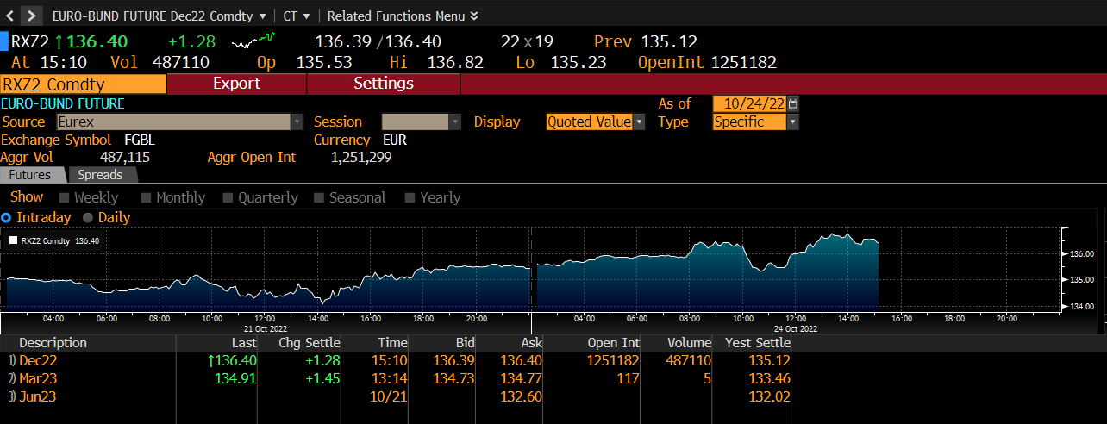

From here we could load the next contract: Mar23. Also now the little calendar month March is highlighted blue indicating the referring month.

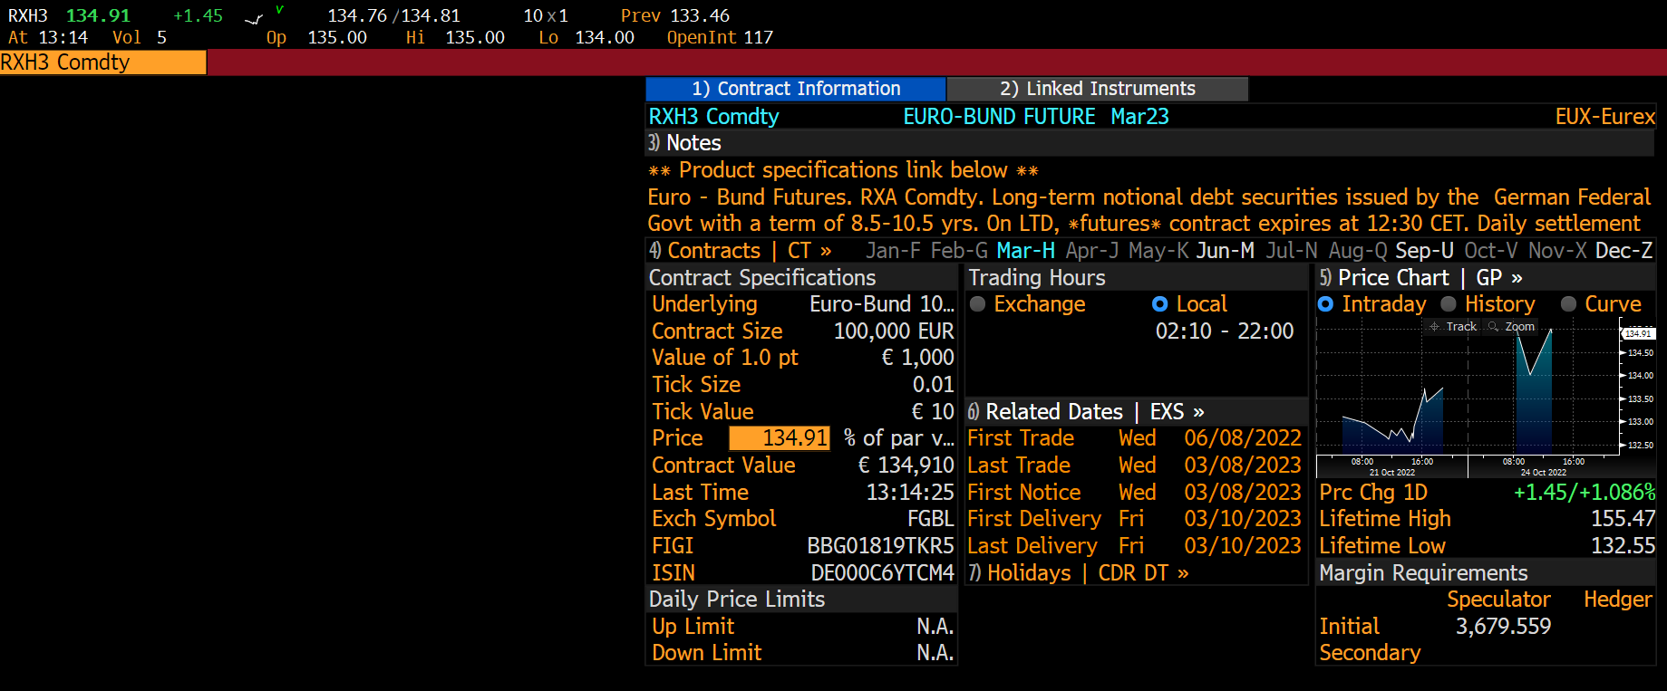

# Section 3: Most important mnemonics

Here one can find a short list with the shortcuts that are more often in use for tasks in the team. It is far from complete and should only offer a quick guidance. Feel free to extend this list by helpful mnemonics and their explanations. We will later take a deeper look on some of them by also providing some use cases/context on how to use them.

## General analysis

**DES** – Access consolidated financial data and fundamental background information.

**BI** – Access industry analyses from Bloomberg Intelligence.

## Currencies

**FCX** – Matrix of currency rates.

## Derivatives

**OMON** – See real-time pricing and market data for call and put options.

**CT** – Overview of the contract table with all currently trading contracts with a light orderbook view.

**OVDV** – Display different volatility related measurements, especially the 3D-Volatility surface.

## Economics

**FED** – Monitor the activities of the U.S. Federal Reserve bank.

**CENB** – Access portals to other international central bank resources.

**ECO** – See economic calendars for upcoming industry and central bank releases.

**ECST** – Monitor economic data from multiple sources.

**ECFC** – See economic forecasts and compare regional forecasts.

## Excel Tools

**XLTP** – Access a library of Excel templates for custom data analysis.

**FLDS** – Locate specific Excel fields for your formulas.

## Equities

**WEI** – Get comprehensive market surveillance for global equities markets.

## Fixed Income

**SRCH** – Search fixed income securities for trends and trade ideas.

**DLV** – Cheapest – to deliver analysis GUI and overview of bond in the futures basket.

**DBFA** – Deliverables Bond Futures Analysis.

**DDIS** – See the maturity distribution of debt for a selected issuer.

**YAS** – Price fixed income securities and calculate yields in one place.

**BTMM** – Assess a country’s current interest rate environment.

**ALLQ** – See dealer-contributed prices in real time for corporate bonds.

**DEBT** – Determine the holders who are most exposed to a country’s debt.

**WB** – Monitor sovereign bond yields, spreads and performance.

**CRPR** – Assess the creditworthiness of an issuer or fixed income security.

**CRVF** – Search for curves that are relevant to fixed income market analysis.

**SRSK** – Get transparent, quantitative estimates of the 1-year default probability of a country’s sovereign debt and 5-year CDS spread.

## News

**TOP** – Get the day’s top worldwide news stories in one place.

**BRIE** – Read Bloomberg newsletters on markets, economics and industries.

## Additional resources

**MSG** – Send and manage Email communications through the Bloomberg.net Email account.

**SECF** – Search for securities by applying custom filter criteria.

**GRAB** – Take a screenshot.

# Section 4: Mnemonics in detail

In this section we will cover a few mnemonics in detail by providing screenshots and some guiding words on how to use them.

## DES – description page

Type in a company or product ticker and directly afterwards: **DES** to get to the General description landing page that houses an overview with basic data. From there on one can go into deeper analysis or just validate if one chose the correct Ticker.

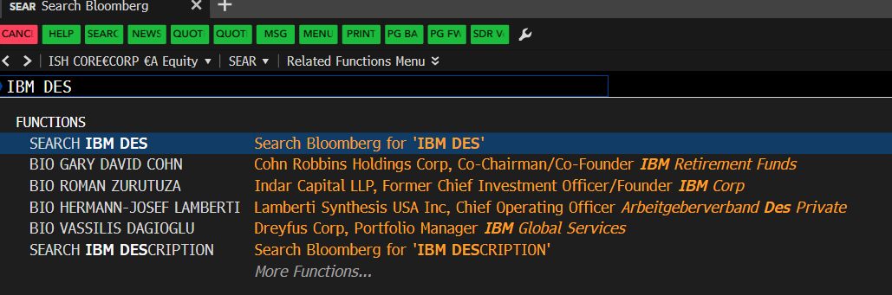

Figure 8: Description page for the IBM stock

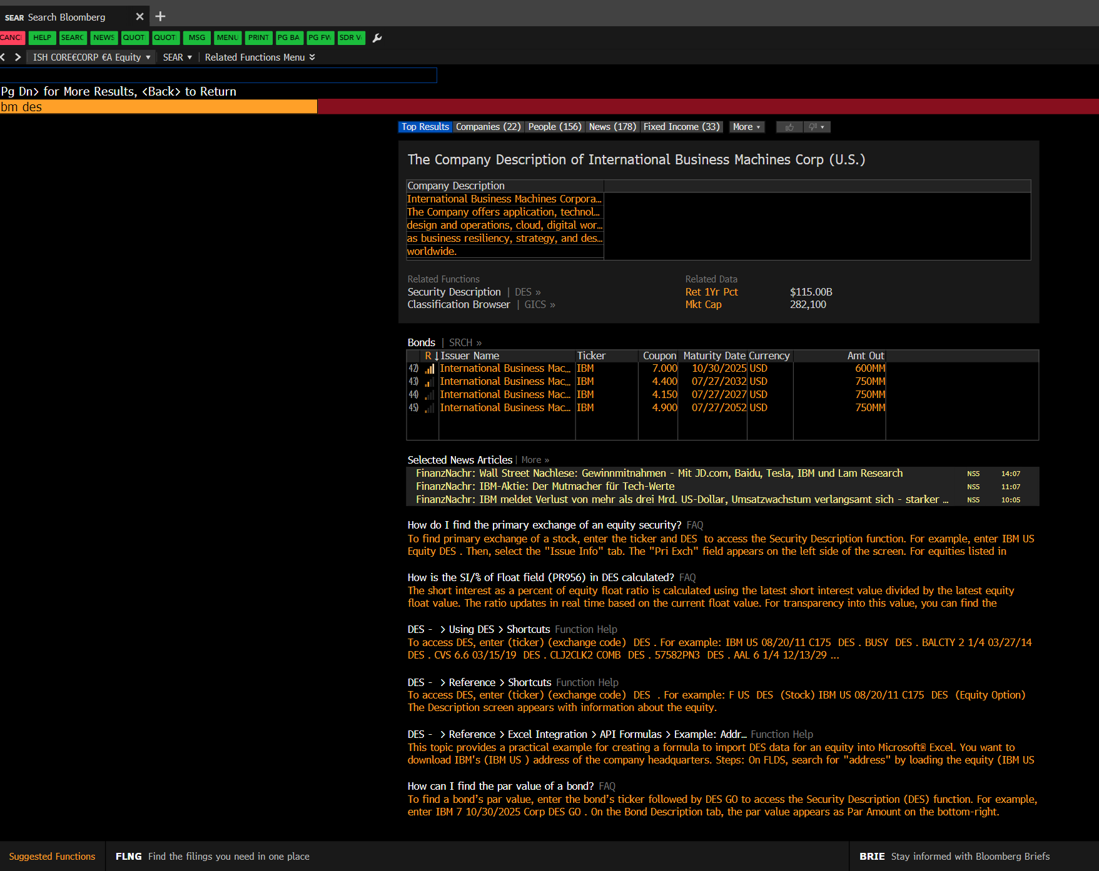

Figure 9: Overview of the IBM description page

The General Description page is almost always a good starting point for analysis, especially when one is not 100% sure what to look out for or if one wants to validate that he has chosen the correct ticker for a security. As one can see there are a lot of further options by clicking on the orange-highlighted fields or words or the little subtabs on the page as indicated by the arrow. Also one can check what other mnemonics are available by clicking the “Related Functions” button above the command line in the upper left area of the tab.

## BI – Bloomberg intelligence dashboards

From anywhere just type in **BI** to get to the Bloomberg-Intelligence page.

If one needs data for a project and is not 100% sure of what to look for the BI function can be a good general starting point. Lets say one wants to monitor the supply chain area or wants to build a tool around this topic then he can search for interesting data points in provided dashboards for this sector.

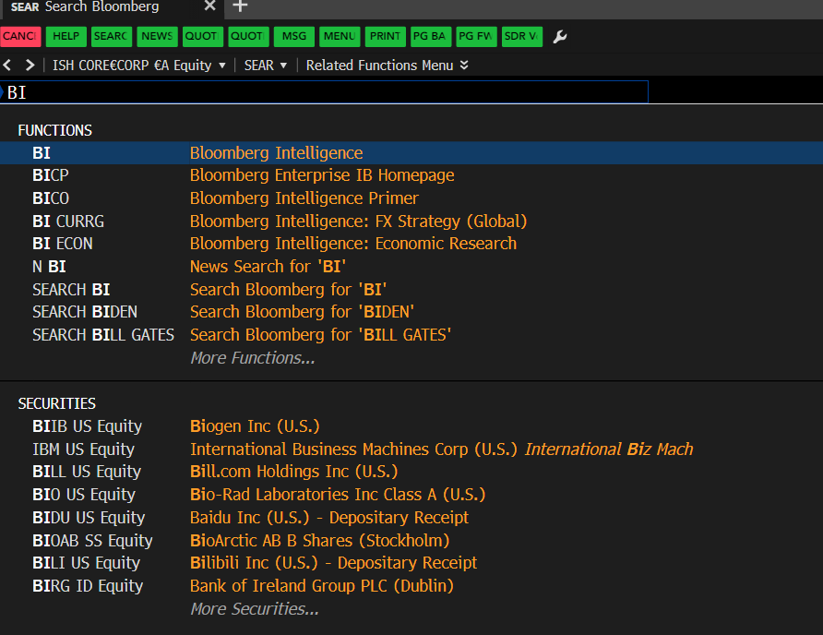

Figure 10: Go to the Bloomberg-Intelligence Page

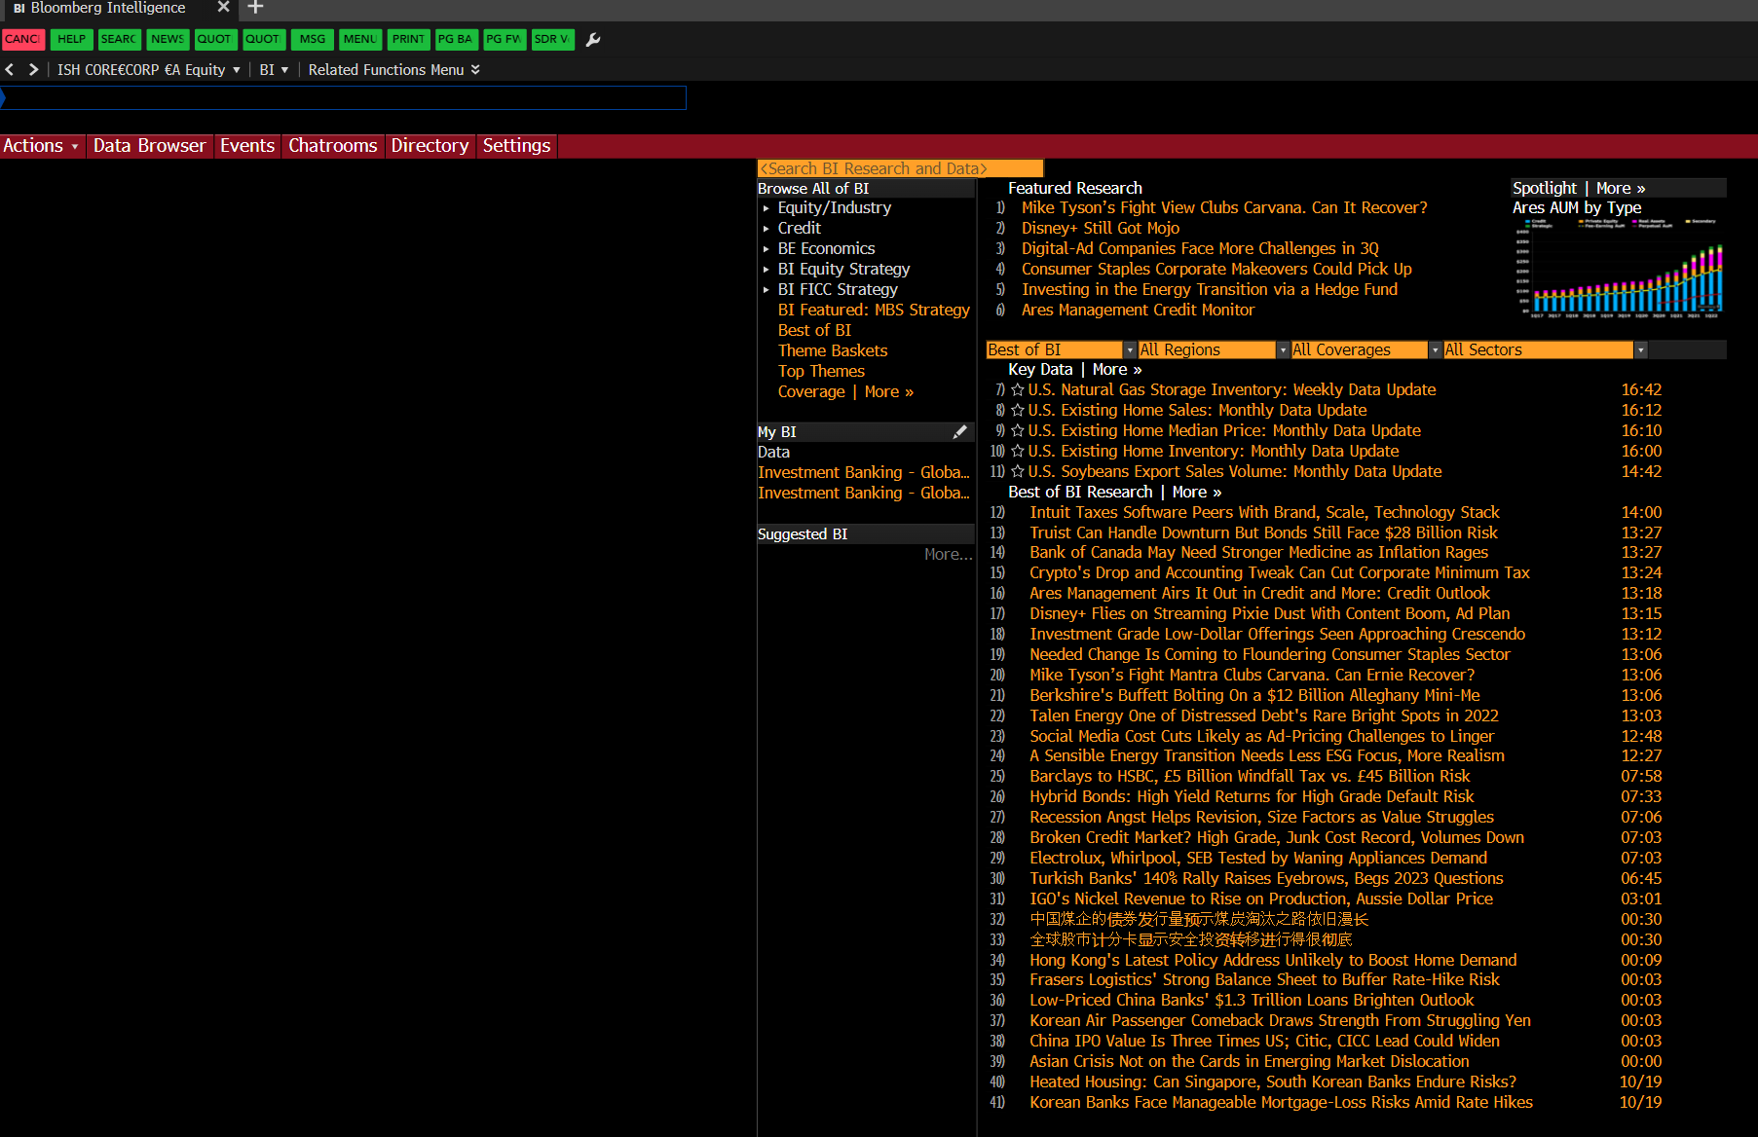

Figure 11: BI Landing Page

In BI one can find set up example dashboards that hold a broad variety of data points to get an overview of a certain area like transport and supply chains. Make sure to directly save interesting dashboards to the favorites list to later find them again as there are plenty of dashboards and subtabs one can easily get lost in.

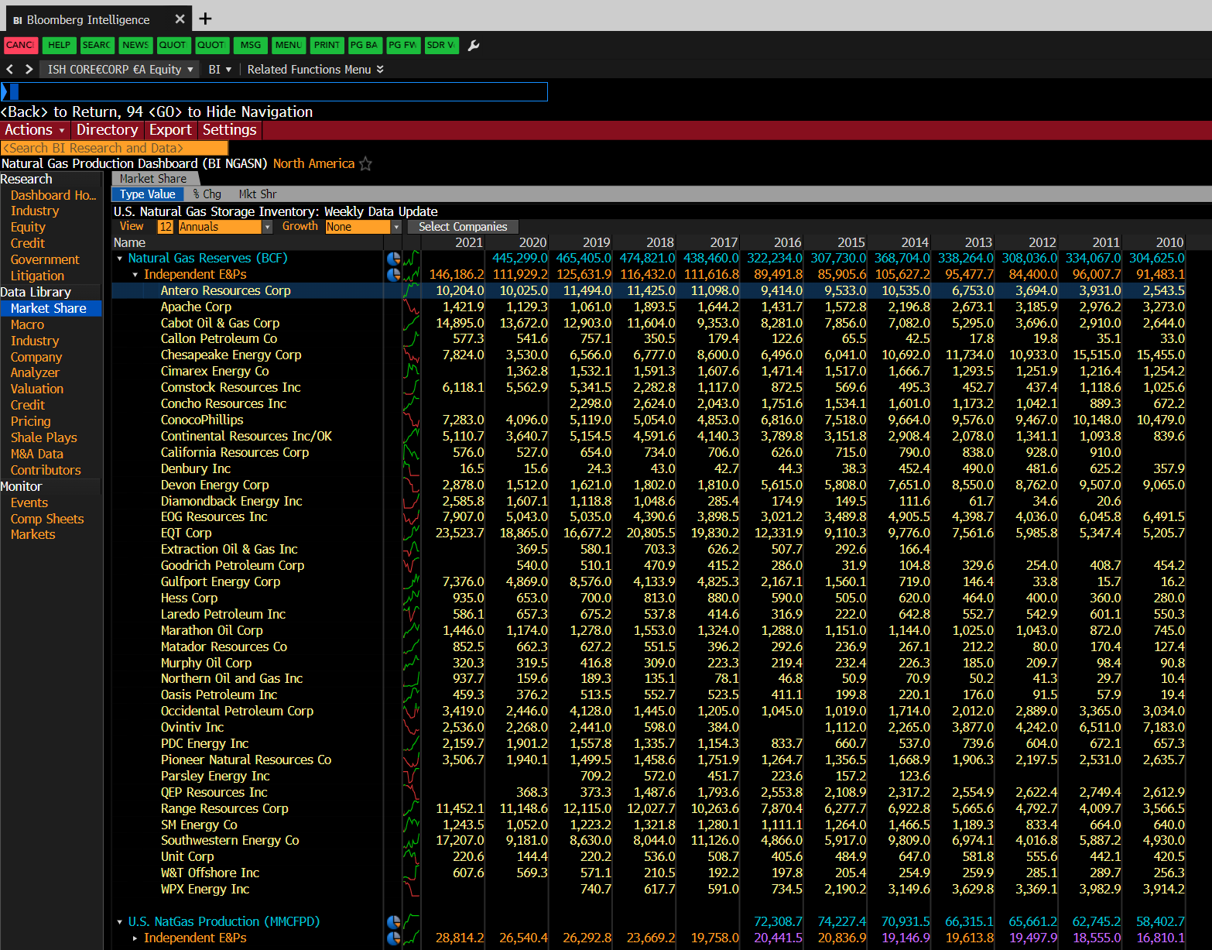

Figure 12: Example Dashboard from BI

Click on an example to get a feeling for the general structure of the BI area of the terminal. As can be seen, the dashboards follow a certain structure where one can navigate areas by clicking on the provided categories on the left site. If one sese an interesting data point just click on it and load it, go to its description page by typing **DES** and save the BL-Ticker for later. Make sure to save some views into the favorites list.

## FXC – Currency Matrix Performance

As the FX derivatives product suite belongs also to the FI PD Team, it is possible that from time to time FX Analysis has to be carried out. Therefore it is a good idea to devote some time to the FX area of the terminal as well. To get to most important exchange rates and their performance one can look at the currency matrix. From there one can also get the needed BL-Tickers of the currency pairs. From anywhere just type in: **FXC**.

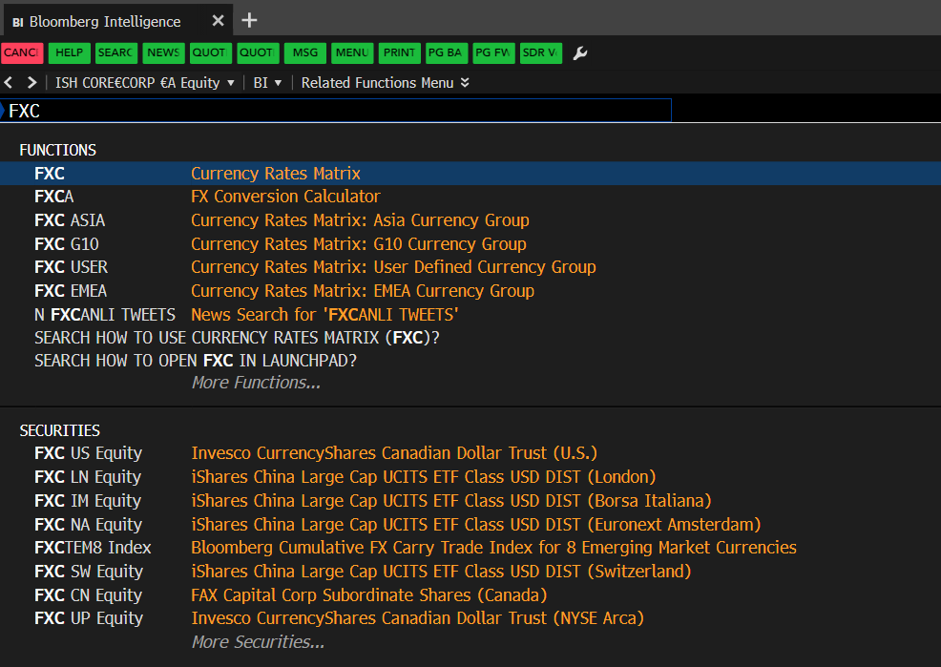

Figure 13: Go to the FCX currency matrix

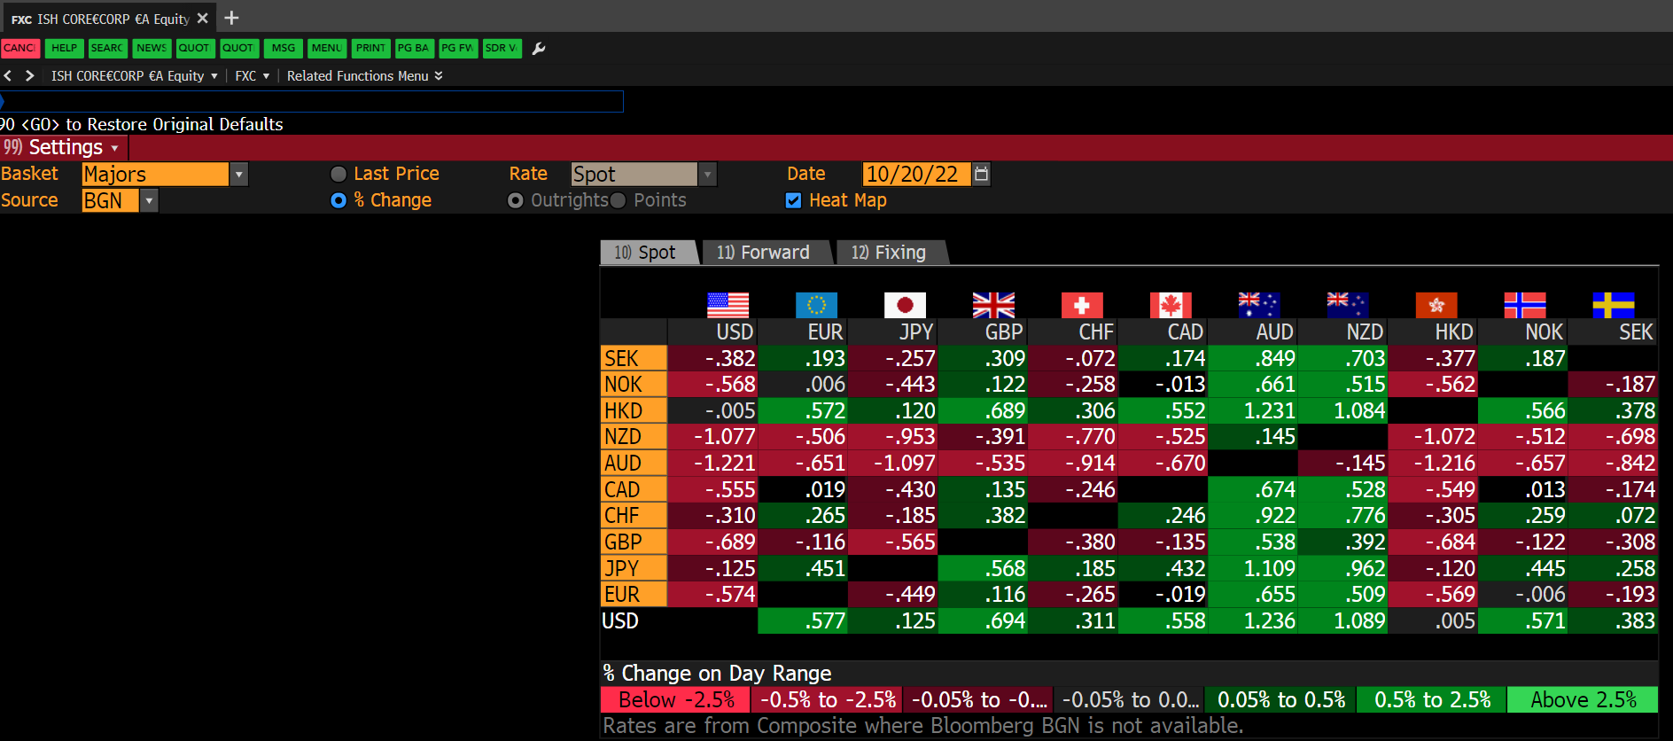

Figure 14: Overview of the Currency matrix

## OMON – Options Monitor

Type in a company or product ticker and directly afterwards: **OMON.** One maybe has to choose an option from the Bloomberg recommendations in the command line to get to the Monitor.

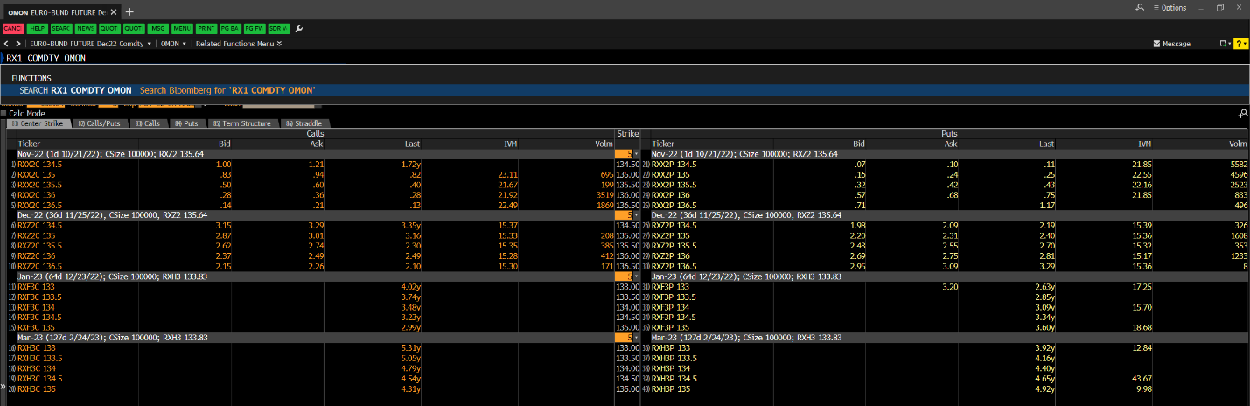

Figure 15: Overview of the Options Monitor of the Euro Bund Future.

In OMON one can see a general representation of the orderbook for Options on the security one typed in. Look at the active contracts and edit the displayed depths for example (multiple strikes) or edit the displayed columns. As we have briefly described the structure of specific contracts (Futures, Options) we can see the unique contract IDs here as well in the rows right next to the names.

## OVDV – Display Volatility measures

From anywhere just type in: **OVDV** to get to the landing page volatility related measurements. You have to provide a security ticker from that you know also Derivatives (Options) exist on, like the S&P 500 Index (BL-Ticker: SPX Index).

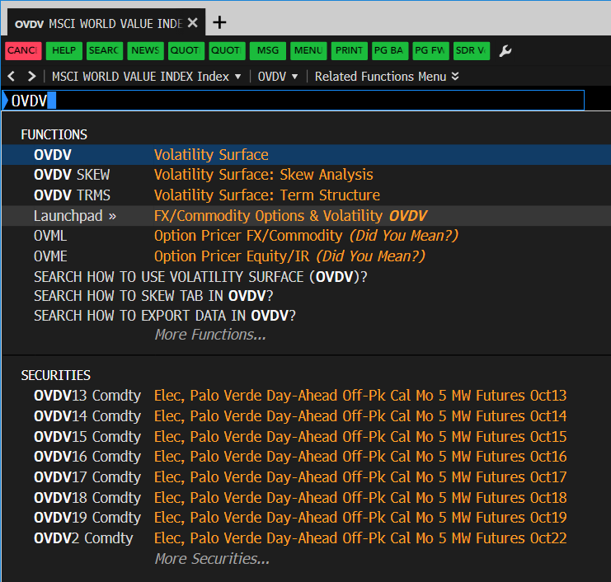

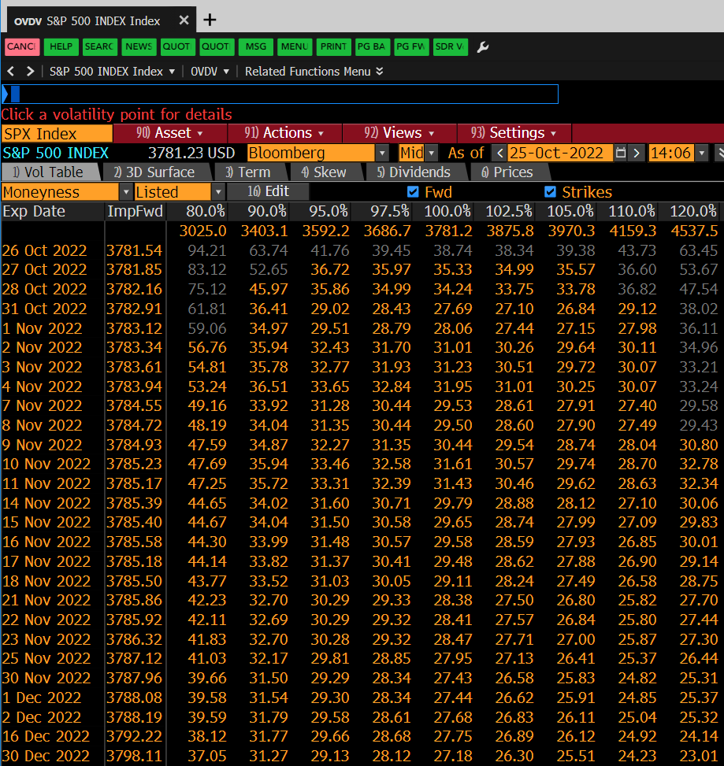

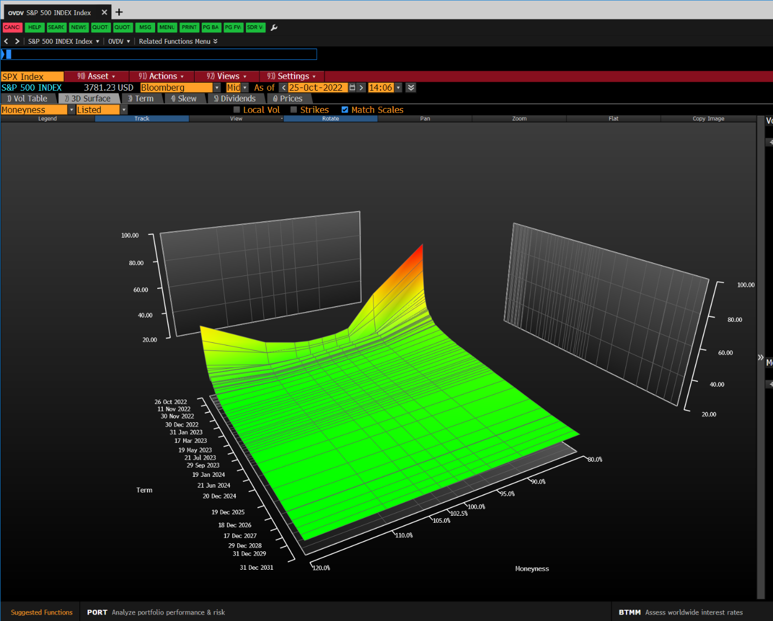

## FED – Federal reserve Analysis

From anywhere just type in: **FED** to get to the landing page of FED activities. As the US plays a major role in the global financial markets its national central bank the FED is always an important source for information of monetary guidance that can impact a broad variety of asset classes, products and economies worldwide.

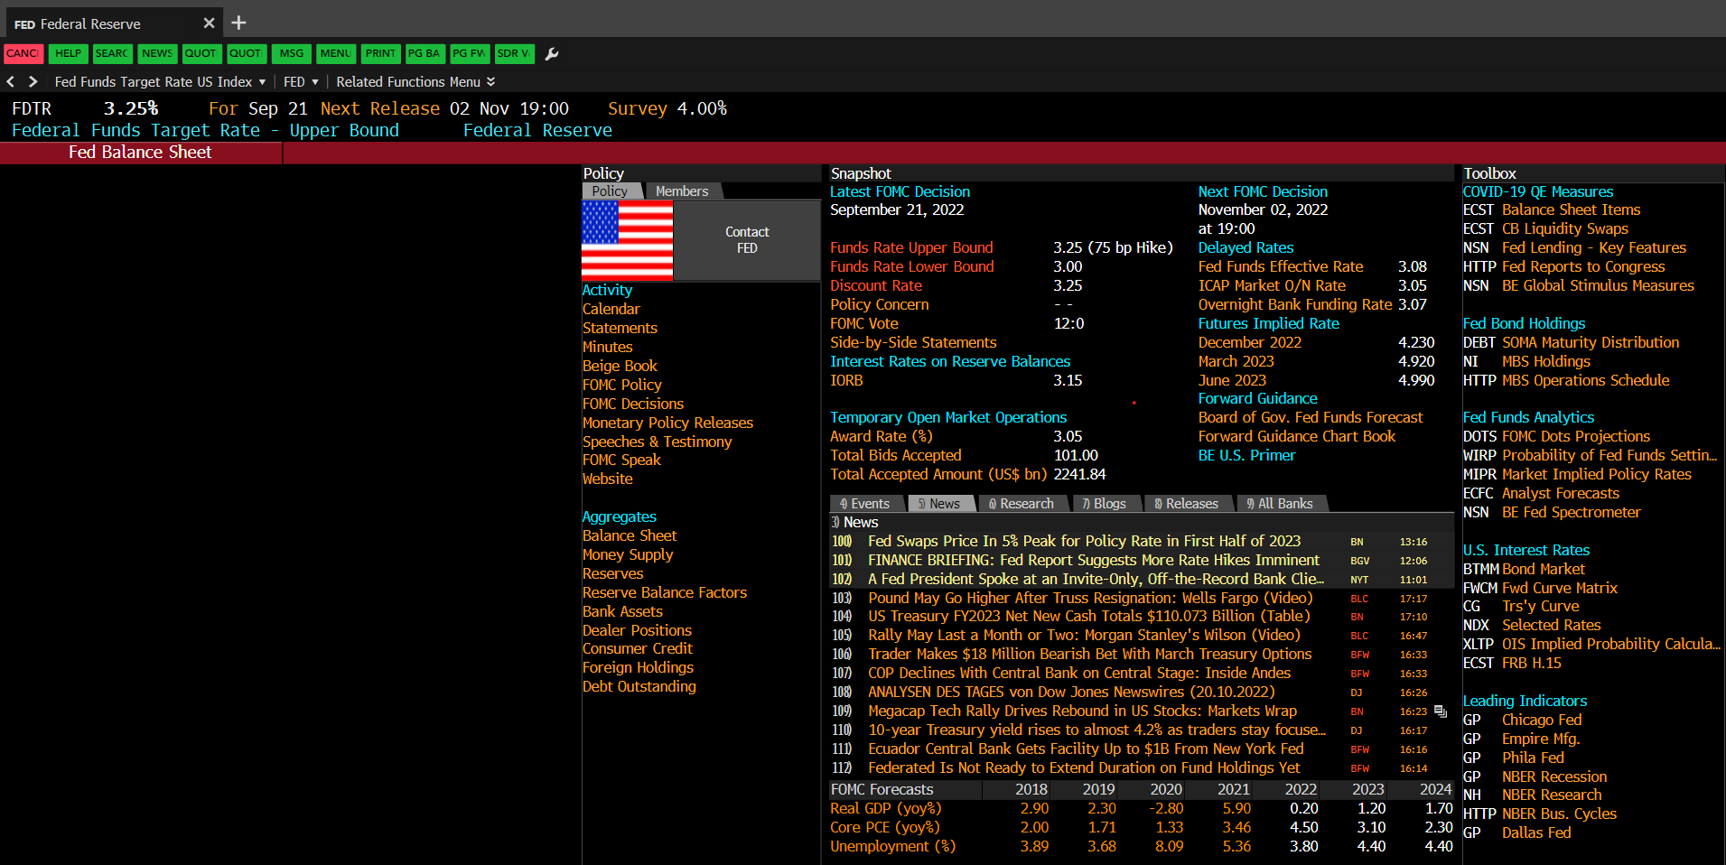

Figure 16: FED landing page

See the next FOMC meetings for guidance or a noteworthy sentence in macro parts for reports, get market implied rates for comparisons and further analytics tools

## ECO – Economics calendar

From anywhere just type in: **ECO** to get to the landing page that houses the release dates for important economic indicators, here related to the US. The economic indicators provide valuable insights and can be included in reports or even graphs to show reactions or responses to their releases in the products or markets.

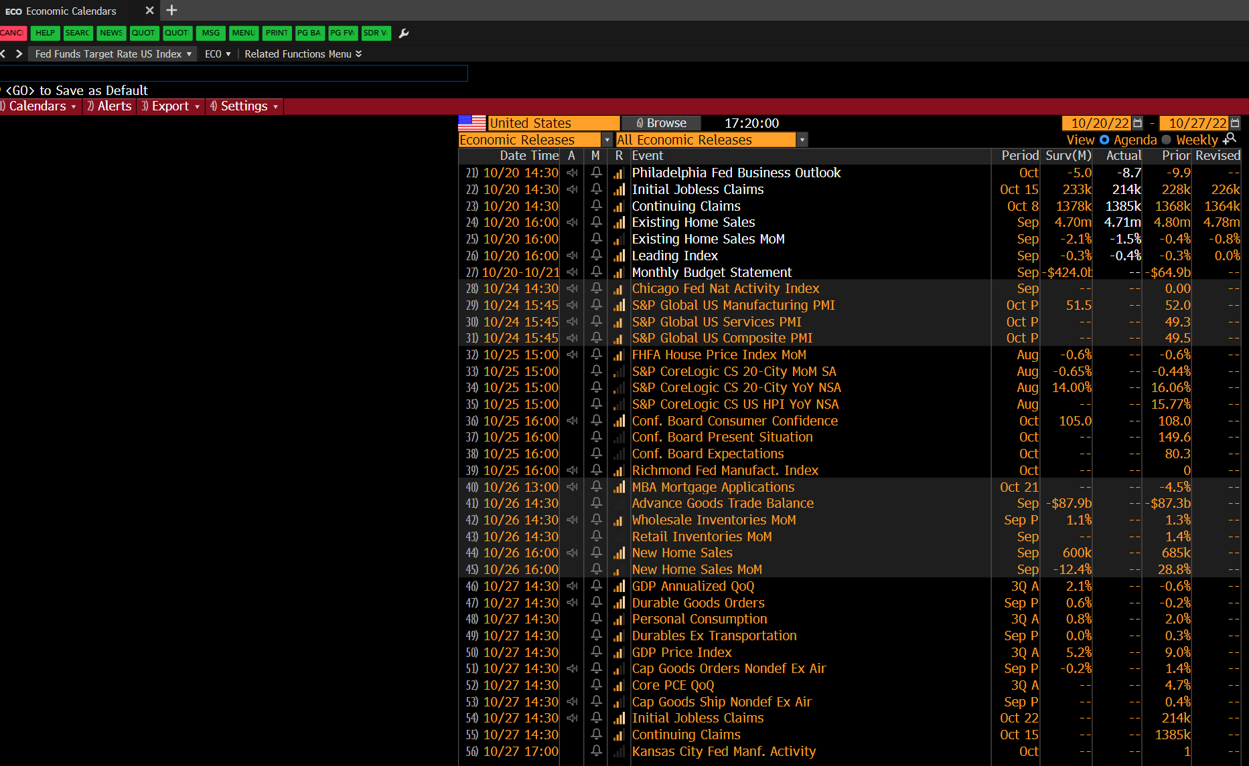

Figure 17: Overview of the releases of important US-related economic indicators

Select the desired geographic region/country and timeframe to see the upcoming awaited variables. The release date of these macroeconomic variables can also be a good idea to include in macro parts in reports.

## XLTP – Excel Template Library provided by Bloomberg

From anywhere just type in: **XLTP** to get to the landing page of excel templates Bloomberg provides their users with.

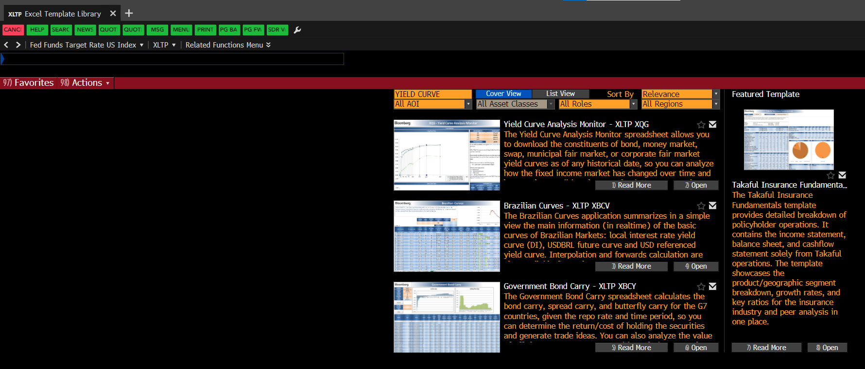

Figure 18: Overview of the Excel Template Library

In the Excel template library we primarily use the Yield Curve Tool, otherwise just type in some keywords in the search bar and download the desired file. Here you can see it popping up directly up front when searched for “Yield Curve”.

## FLDS – Fields

**This function is one of the most important ones as it shows you the available data points for each security.**

Type in **FLDS** and a security for which you want to see what data you can get for it. Under normal circumstances we use historic data on several frequencies (Daily, Monthly, etc.) so we can filter by the “Field Type” and select the “static historic data” and type in a keyword in the Search Bar. In terms of Volume and Open Interest we use the two fields shown directly up front as standard setting.

**How we can use these data fields, we will see at a later point in the case studies where we will use the Excel Add In to load data in Excel files.**

If you want a more detailed description of how the fields are computed just click on them to get more information. If there is data available, the most recent data point will show up directly in the column “value” to get a first indication if you chose the right field.

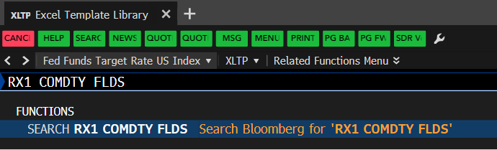

Figure 19: Look up the available data fields of the Euro Bund Future

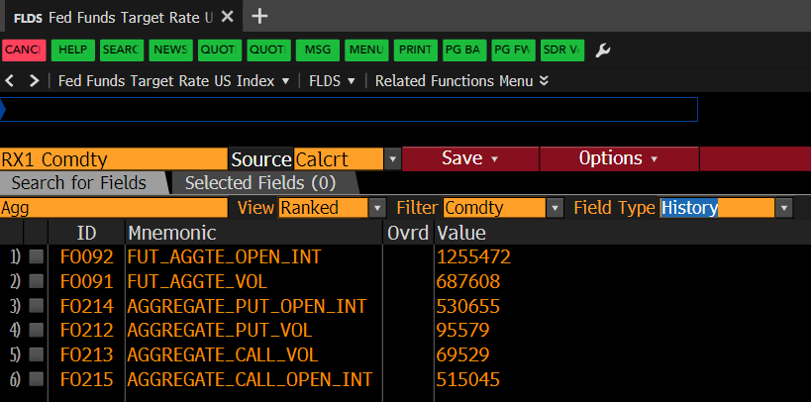

Figure 20: Look up for Data Field with which one can get the Aggregate Volume of the Euro Bund Future in the data fields finder

Here for the 1st Generic Euro Bund Future we see the most common data fields we use for retrieving Volume and Open Interest data.

For **Future Volume** data we use the data fields:

**FUT_AGGTE_VOL** (See the Excel Add-In Case Studies later on)

This data filed gets you the summed up Volume of all current tradable futures contracts (In total 3 contracts under normal conditions).

For **Future Open Interest** data we use the data fields:

**FUT_AGGTE_OPEN_INT** (See the Excel Add-In Case Studies later on)

This data filed gets you the summed up Open Interest of all current tradable futures contracts (In total 3 contracts under normal conditions).

If we are faced with Options (on Futures) we have to apply a slightly different method to arrive at the Volume and Open Interest Figures.

Since Options have a Call and a Put site, we have to just manually sum up the Aggregate Call and Put Volume, and of course do the same for the Open Interest, so we need the following Data Fields:

For **Options (on Futures) Volume** data we use the data fields:

**AGGREAGTE_CALL_VOL**

**AGGREAGTE_PUT_VOL**

For **Options (on Futures) Open Interest** data we use the data fields:

**AGGREAGTE_CALL_OPEN_INT**

**AGGREAGTE_PUT_OPEN_INT**

## SRCH – Search

From anywhere just type in: **SRCH** to get to the Fixed Income search landing page.

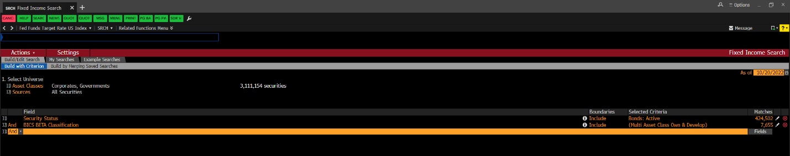

Figure 21: Landing page of the fixed income security screener for long lists

With SRCH you can establish long lists of fixed income securities. One by one, just add filter criteria to narrow your result down. This feature comes in handy when, for example, screening for ESG or SRI bonds to build graphs and market shares of how the industry evolves. If f you are done with a screen, click on “result” in the lower right corner to show the search result. Make sure to save your custom search for later or use saved searches from team members to replicate/update their results for reports lets say.

Depending on your screening result it may be the case that your results list is very long and overshoots the limit the terminal lets you download as excel file, in this case you can could think about applying additional filter criteria to just lower your results temporarily for exporting reasons: you could add another size criteria to split your data set so that you first export the first half and then switch the criteria and export the other half of the results to get everything as planned.

## DLV – Deliverable Bonds – CTDs

From anywhere just type in: **CTDS** to get to the landing page that houses the deliverable basket of bonds underlying the futures contract. Here you can easily figure out which bond is gonna be the CTD and also the durations, conversion factors and implied repo rates.

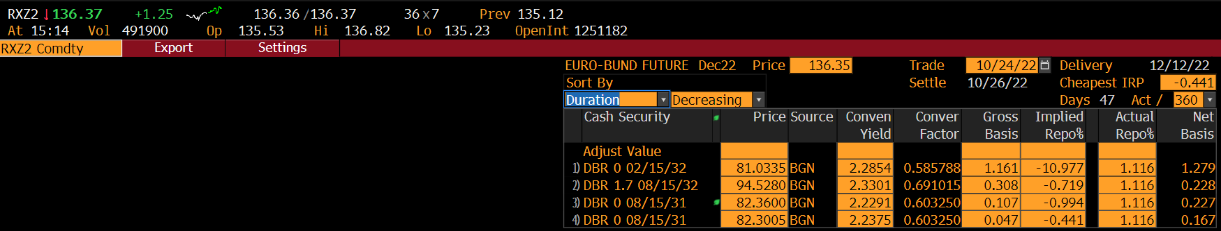

## DBFA – Deliverables Bond Future Analysis

From anywhere just type in: **DBFA**  to go to the analysis monitor of the deliverables for futures contracts. Here you can do deeper analysis on Bonds.

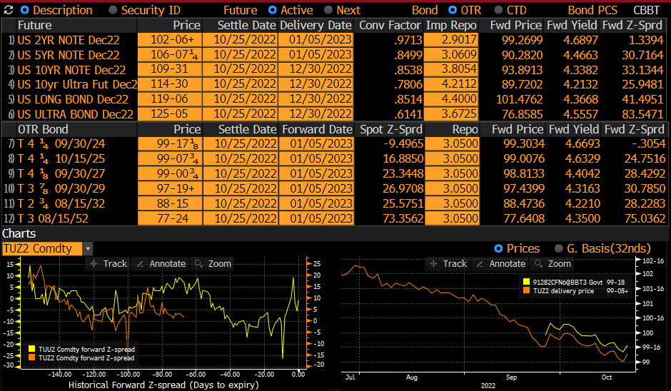

## WB – World Bond Markets

From anywhere just type in: **WB** to get to the overview page of the world bond markets that exists as the counterpart to the **WEI** function (World Equity Indices).

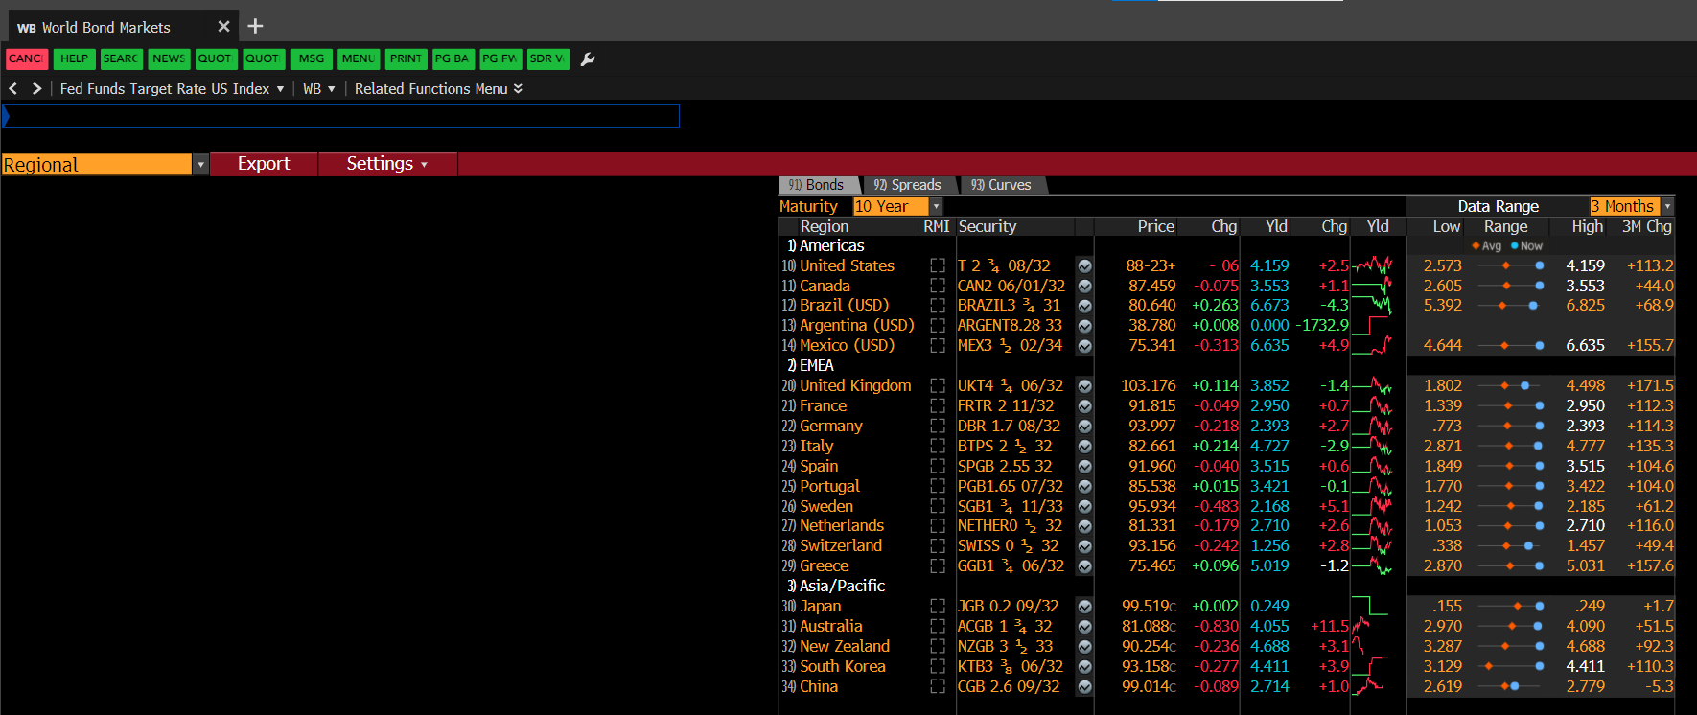

Figure 22: Overview of the world bond markets

With WB one can get a quick overview of the current situation on the world bond markets. Select the criteria as needed. Here you can also do sanity checks if you have chosen the correct actual bond as tenor for lets say 10Y tenor for Germany or other countries.

## CRVF – Curve Finder

From anywhere just type in: **CRVF.** With the Curve finder we can identify the actual or historic yield curves for corporates or governments. The IDs of the curves can be for example used in the Excel Yield curve tool from the Excel template library to compare the yield curves at different points in time.

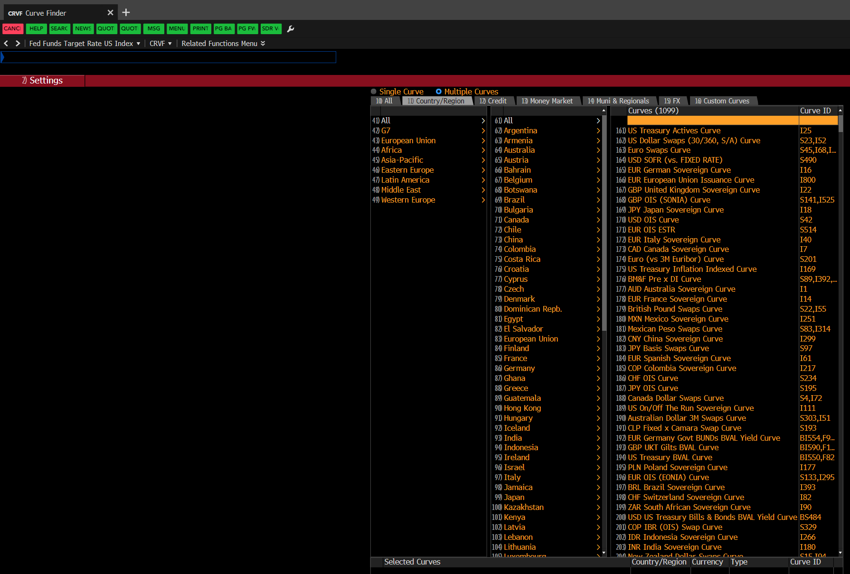

Figure 23: Yield Curve ID Finder

Here you can narrow your search down or search for specific curves, the IDs are the important data points to extract here.

## TOP – Top News

From anywhere just type in: **TOP**. You could also add keywords like “Energy” or “Germany” to see top news for your custom topic.

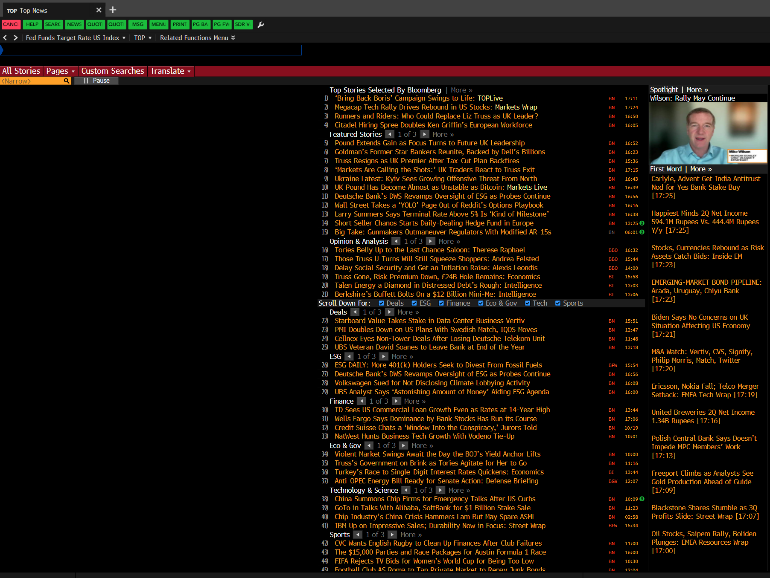

Figure 24: Landing page of the Top news articles

As the new are being constantly updated intraday you should be advised to save interesting articles immediately as it can be hard to fund them again afterwards.

News articles could be a good starting point for research on data points, variables, or current topics to include in the macroeconomic parts of reports.

## MSG – Messages/Emails

From anywhere just type in: **MSG.**

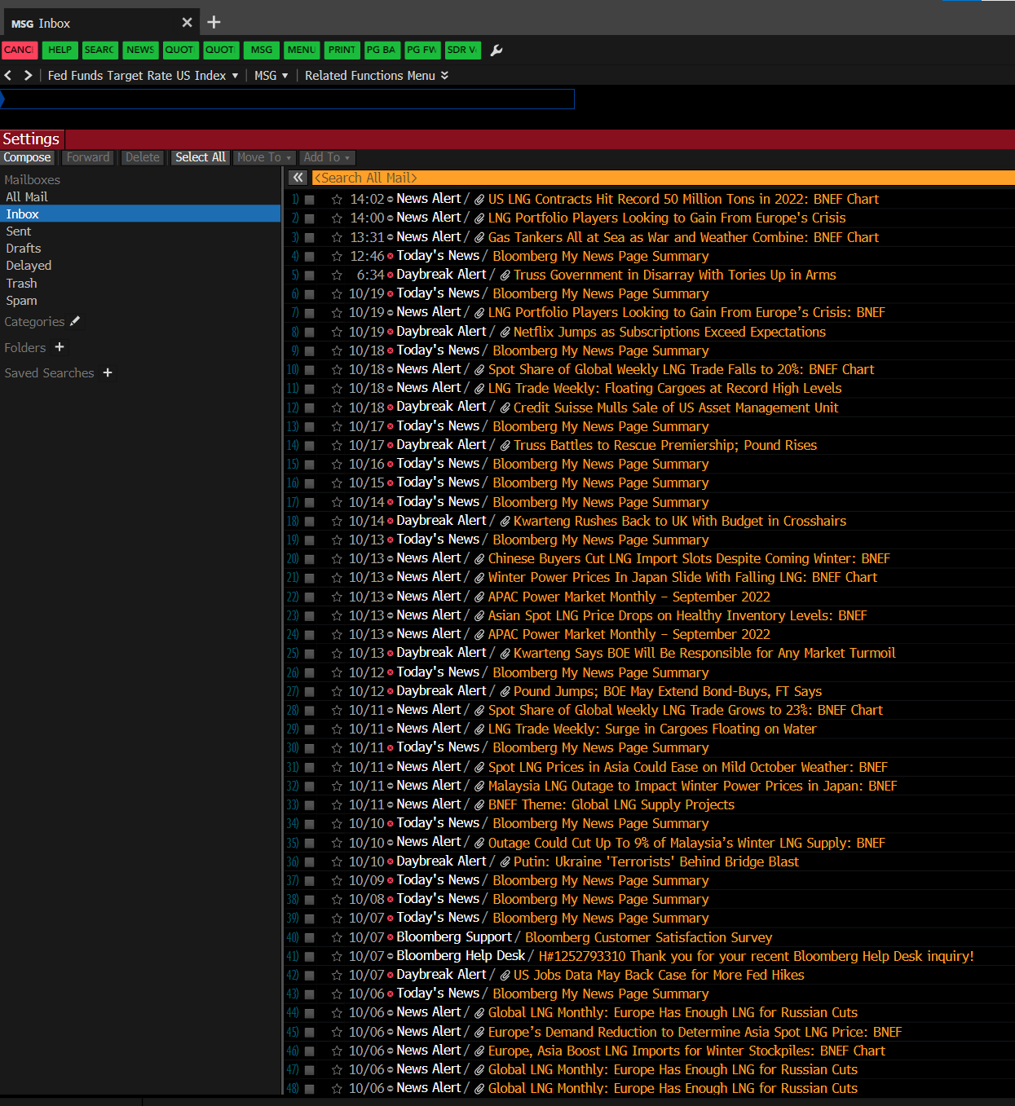

Figure 25: Messages Inbox

Every Bloomberg User is provided with his own Bloomberg specific Email account to be contacted by other users in the network. So there is an own inbox and Email system with which you can send views, links to articles or screenshots just to name a few options.

## GRAB – Send screenshots

From anywhere just type in: **GRAB**.

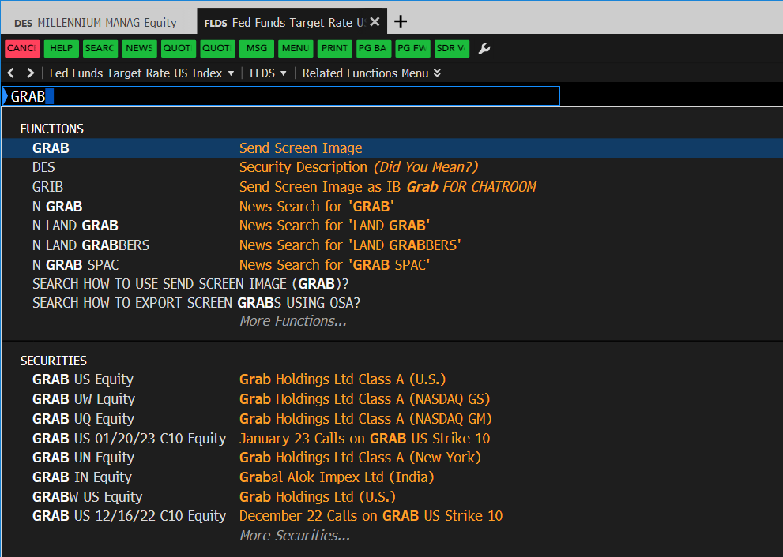

Figure 26: Grab Screenshot function

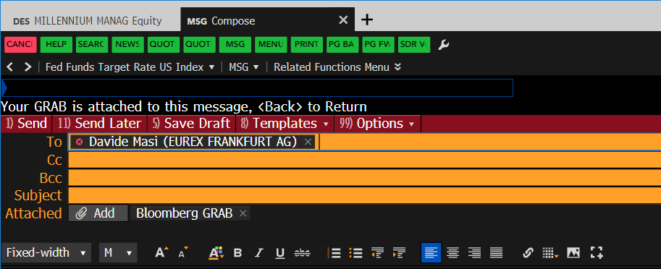

Figure 27: Message Inbox sending out a Screenshot

GRAB creates immediately a screenshot of your current open tab, you could then for example send a team member to his Bloomberg account Email or to an external Email account. When you want to have more options in editing your screenshot you can also press Windows key + Print to get more editing tools to work with.

# Section 5: The Excel Add-In, Formula Syntax and Data Types

In this section we want to look at how we can conveniently load data into the excel environment and what the typical syntax of Bloomberg formulae looks like. In that regard we will also get to know some differences of data types used.

## The Excel Add-In

To get the desired data for further analysis, Bloomberg offers the Excel-Add In you can find in any Excel file you open or start.

**When you want to load data, it is necessary that you are logged into your account in the application of the PC, otherwise you will not be able to get data. So, you need be logged in the whole time you are working with files that contain Bloomberg formula syntax to update them or in the first step even create them. Keep this fact in mind for a later exchange of the files for team members, we will come back to that later.**

You can of course always export certain data directly from the Terminal manually by clicking on the “Export” Button on some screens, but the way more convenient variant is to use the simple syntax in the excel files. Go to the Bloomberg Excel Ribbon.



Figure 28: The Export Button inside of the terminal

Getting help on the Ribbon: **BESS <GO>:** A video tutorial on API (Bloomberg Data in Excel).

**DAPI <GO>**: Opens the Bloomberg excel add in menu within the Terminal and provides information on Bloomberg formulas and functions

An extensive guide can be found here: <http://www.library.fa.ru/files/bloomberg-excel.pdf>

The excel Ribbon view:

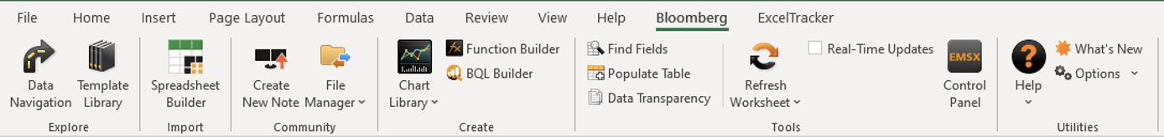

Figure 29: The Excel Add In Ribbon

Here the most important areas are**: “Spreadsheet Builder”**, **“Function Builder”, “BQL Builder”, “Find Fields”** and to later update your created/already existing files: **“Refresh Worksheet”**.

In case the Bloomberg Ribbon from the screenshot above wont appear in your currently open excel file you should follow the below presented steps.

### Installing the Bloomberg Excel Add In

Click on the windows button on your keyboard and look out for the Bloomberg Folder:

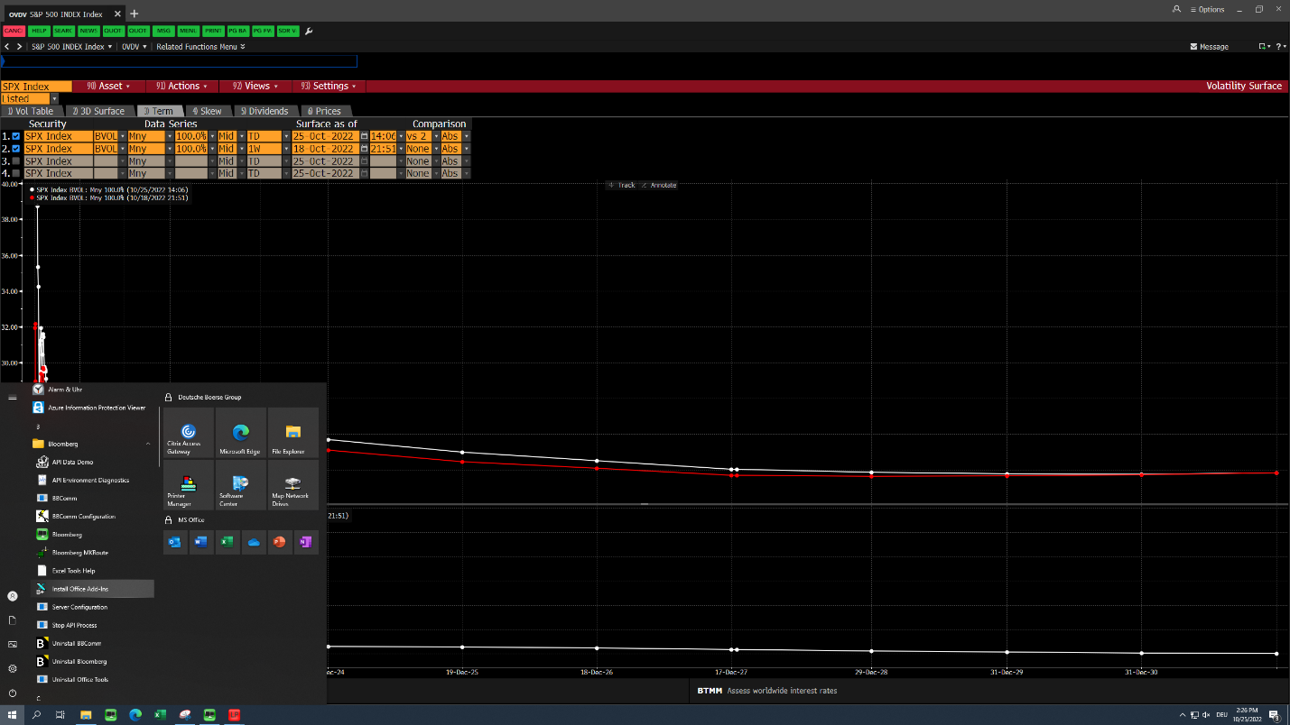

There, click on the button “Install Office Add-Ins” and follow the presented instructions. Afterwards you might have to close and restart your excel application to see the ribbon.

## The Spreadsheet Builder

The Spreadsheet Builder is the fastest and most comfortable way to load data in the sheet. With the Builder you will go through an intuitive five step process that consist out of the following steps:

1. Select the type of analysis that should be carried out (Select the “Historic Data Table” as it is the most often used type in the team)
2. Provide the BL security tickers for which to load data
3. Search for the data fields for the securities

**(See the used Volume and Open Interest Fields in the FLDS section)**

1. Select the daterange, frequency and additional parameters (not really necessary)
2. Final Check and preview of the data

The single steps can be followed by the screenshots below.

**Step 1)**

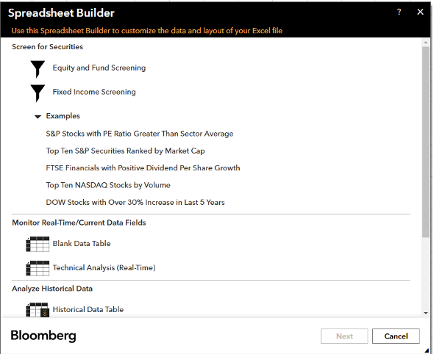

Figure 30: Spreadsheet Builder – Step 1)

**Step 2)**

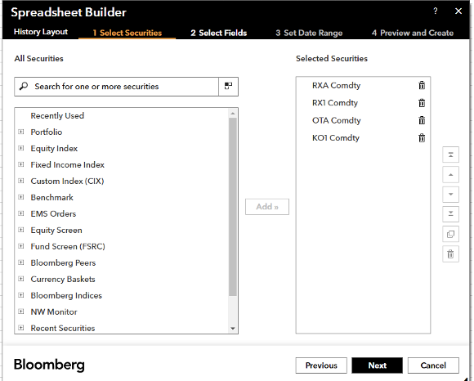

Figure 31: Spreadsheet Builder – Step 2)

**Step 3)**

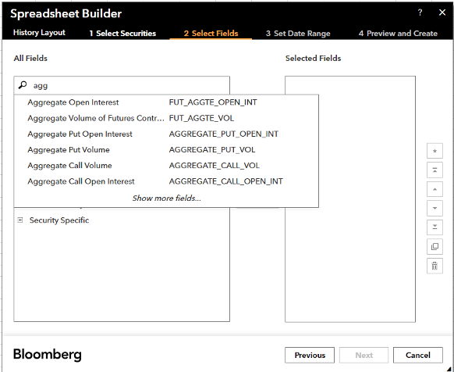

Figure 32: Spreadsheet Builder – Step 3)

**Step 4)**

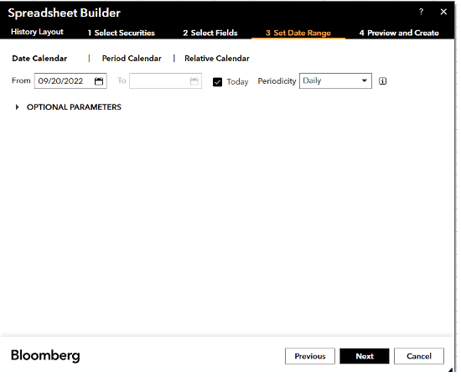

Figure 33: Spreadsheet Builder – Step 4)

**Step 5)**

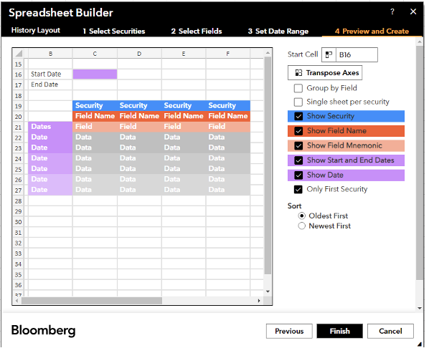

Figure 34: Spreadsheet Builder – Step 5)

A possible result looks like the screenshot below. If you are selecting the first Date cell you can see the full Bloomberg formula with its single components. By now you will probably be able to see similarities with normal function syntax from any programming language and in that sense, you can change the arguments of the formula (e.g. change the “Per =M” to “Per=D” and see what is happening).

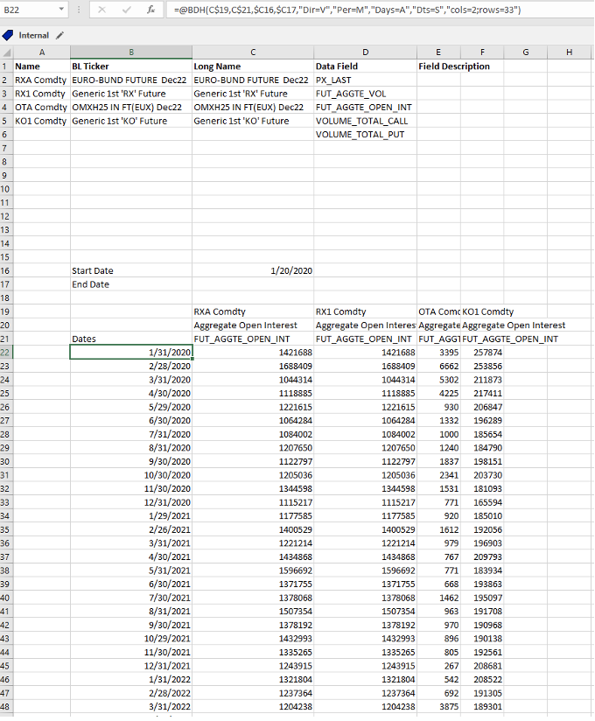

Figure 35: Spreadsheet Builder – Result

In this case we can see that the ”Historic Data table” makes use of the @BDH (Bloomberg Data History) formula. Besides the @BDH variant there is the @BDP (Bloomberg Data Point) and the @BDS (Bloomberg Data Set) option, we will inspect closer below in the function builder.

## The Function Builder

Maybe you are used to the convenience of the documentations of programming languages, that can be somehow matched by using the function builder in the Bloomberg world as there is no complete documentation available. The function builder essentially does the same that the previously looked at Spreadsheet builder does but on a more manual version. We can actively choose what kind of data type we want to get up front (BDH, BDP or BDS). The most important fact is that we can look up single function arguments in the GUI of the function builder, just like a documentation of programming languages.

For example: Open the function builder, select the BDH option and provide a BL-Ticker for a security in the first argument placeholder spot, then go to the space where it says “override names” and type in some keyword like “Period”. You can see a function argument that is being recommended with further information on what options you can choose for the function argument (like “D” for a daily data frequency or “M” for a monthly frequency).

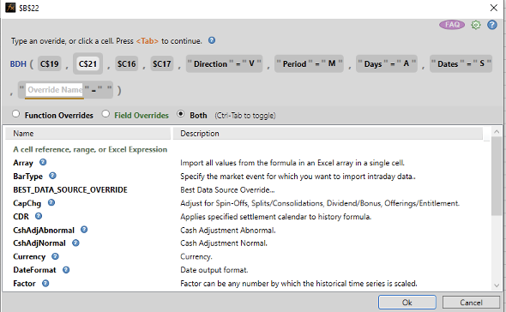

Figure 36: The Function Builder

So you can build custom functions that suit your needs, in a more advanced way than using the Spreadsheet Builder.

### BDP

If you want to get load single Data points then the BDP variant is the best choice. You just have to provide a BL-Ticker and a data filed like “NAME” or “DES” to get a single data point for the security. This formula contains ONLY one security and ONLY one field. BDP follows the syntax:

**=BDP(Security, Data Field)**

### BDH

If you need to display a longer historic time series then the extensively covered BDH data type has to be chosen with the according input parameters. BDH follows the syntax:

**=BDH(Security, Data Fields, ”Start Date”, “End Date”, “Further optional arguments”)**

### BDS

BDS (Bloomberg Data Set) returns multi-cell descriptive data to your Excel spreadsheet. BDS follows the syntax:

**=BDS(Security, Data Field, “Further optional arguments”)**

## The BQL Builder

The Bloomberg Terminal is based on a licensing/Account structure. Every Terminal (with multiple User Accounts on it) has a certain Data limit per month that can be manually extended by writing the support in urgent cases. Every time you click on the “Refresh Worksheet” Button in the Excel Ribbon in an Excel file, the data limit is reduced by the amount of data fields retrieved so it might be a good idea to use BQL for very formula and data heavy files/heavy data loading. BQL can solve custom computations directly so that you can save time and data capacity. It can be problematic to download so much data in bulk when all you really need is the result of a calculation, such as the average price per sector of the FTSE 100 over the last 50 days. (In this example, you would have to download for all 101 securities the price for each day and sector code, that adds up to 5,151 data points when you only need one per sector). The actual use cases are:

* BQL can consolidate fields to make custom fields.
* BQL can reduce the number of tickers you need to use (for example, study sectors within an index instead of every member).
* BQL offers functions to aggregate or group fields (such as average or sum).

You can read further guides especially tied to the Fixed Income Markets and BQl here: [Bloomberg_Fact_Sheet_BQL_for_Fixed_Income_.pdf (wu.ac.at)](https://www.wu.ac.at/fileadmin/wu/s/library/databases_info_image/Bloomberg_Fact_Sheet_BQL_for_Fixed_Income_.pdf)

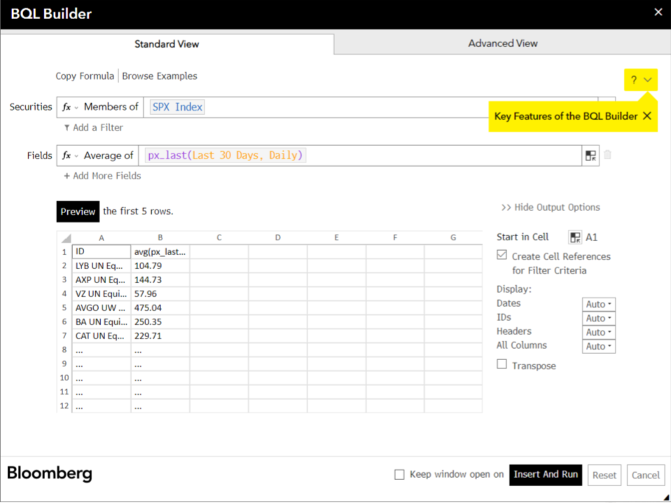

Figure 37: BQL Builder

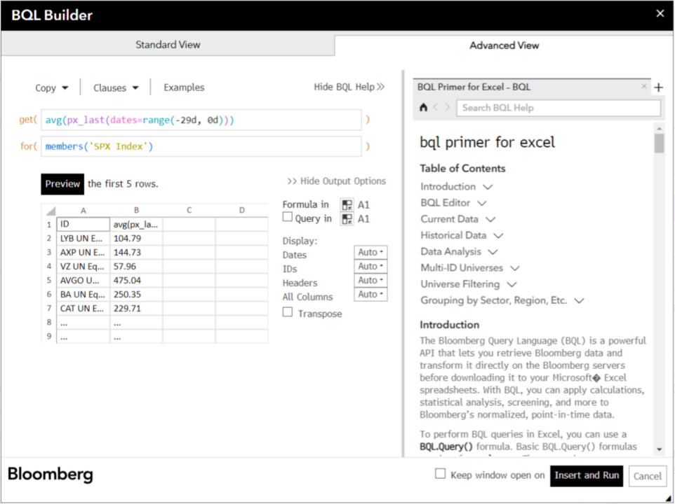

Figure 38: BQL Builder

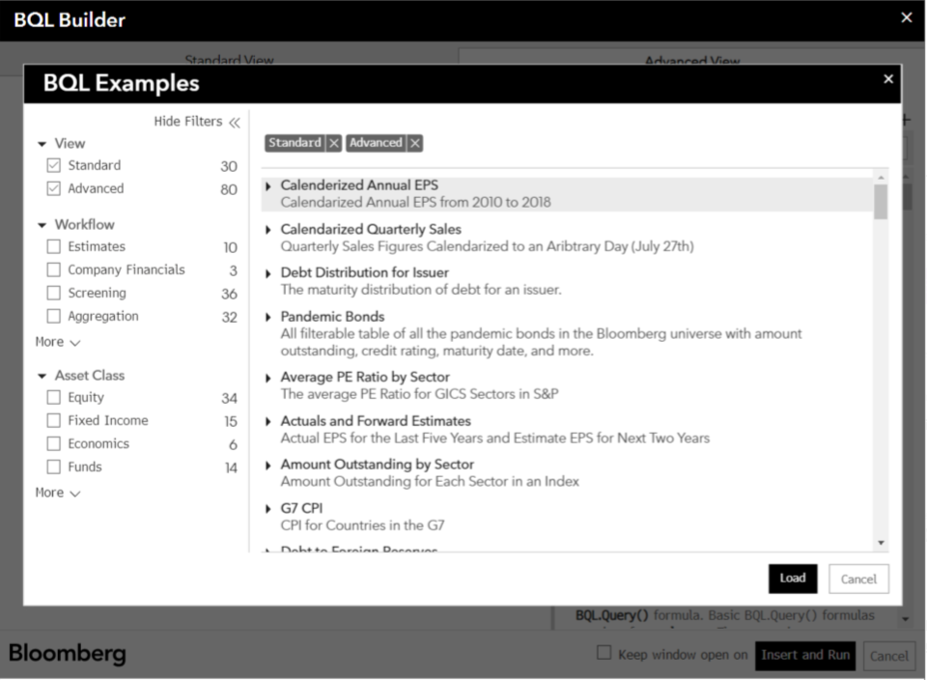

Figure 39: BQL Builder

At its simplest, a BQL function can look the same as a BDP (data point) function. We start with a short example of Apple Inc’s last price (the PX_LAST item). The functions require a security (ticker) then the data item.

* using BDP =BDP("AAPL US Equity", "PX_LAST")
* using BQL =BQL("AAPL US Equity", "PX_LAST")

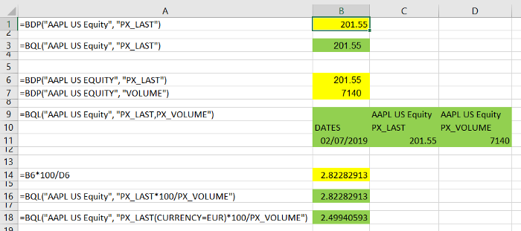

Figure 40: BQL Formulae examples in excel

With BDP, if you want to get a second data item, price volume (total number of shares traded that day), you must write a new formula in a new cell. The With BQL, you can extend the list of data items in the one formula with a comma; this will give you an array of data.

* using BDP =BDP("AAPL US Equity", "PX_LAST")

and =BDP("AAPL US Equity", "VOLUME")

* using BQL =BQL("AAPL US Equity", "PX_LAST,PX_VOLUME")

What if you want to look at percentage ratio of last price and price volume? BQL lets you perform a calculation on the Bloomberg server and download just the result.

* using BDP write another formula in another cell like =B6*100/B7
* using BQL=BQL("AAPL US Equity", "PX_LAST*100/PX_VOLUME")

BQL will download just the one result value instead of downloading many.

There are ‘override’ options you can apply to data items, such as currency. The overrides vary between data items, you can read about them in the terminal with the FLDS function. For BDP, you can only apply overrides at the end of the formula, for all data items. For BQL, you can also apply overrides to individual data item, using brackets:

=BQL("APPL US Equity", "PX_LAST(CURRENCY=EUR)*100/PX_VOLUME")

Getting help for the BQL syntax

Type in the command line in the terminal: <BQLX> and hit enter to go to the reference pages. 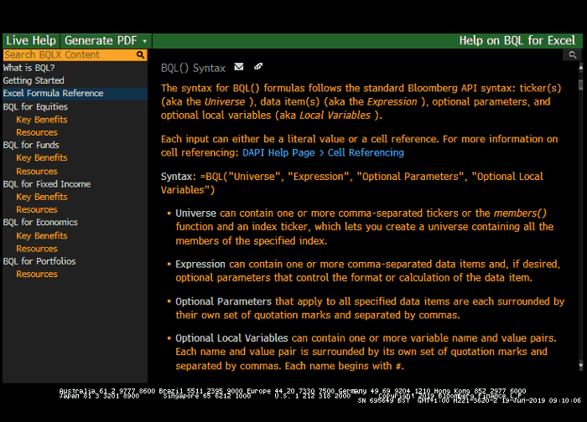

Figure 41: BQL Reference Page

Here you can also find links to video tutorials, fact sheets, tutorials and function reference tables, these can be especially useful as they come closest to traditional documentations of programming languages:

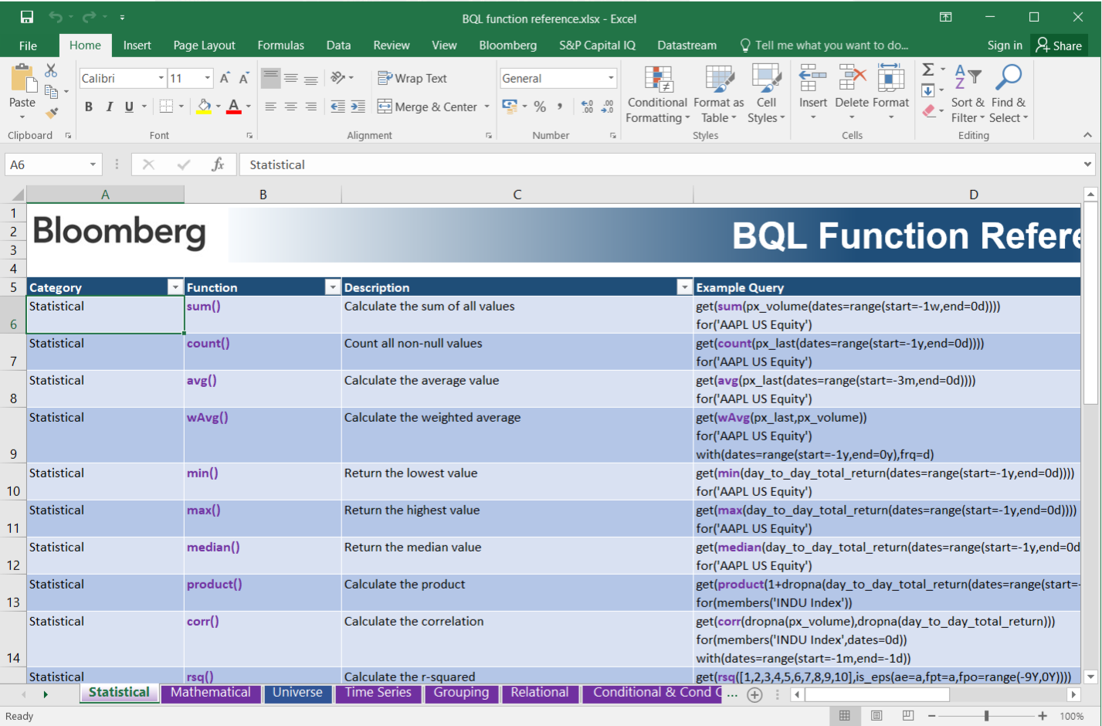

Figure 42: BQL Reference Excel Files

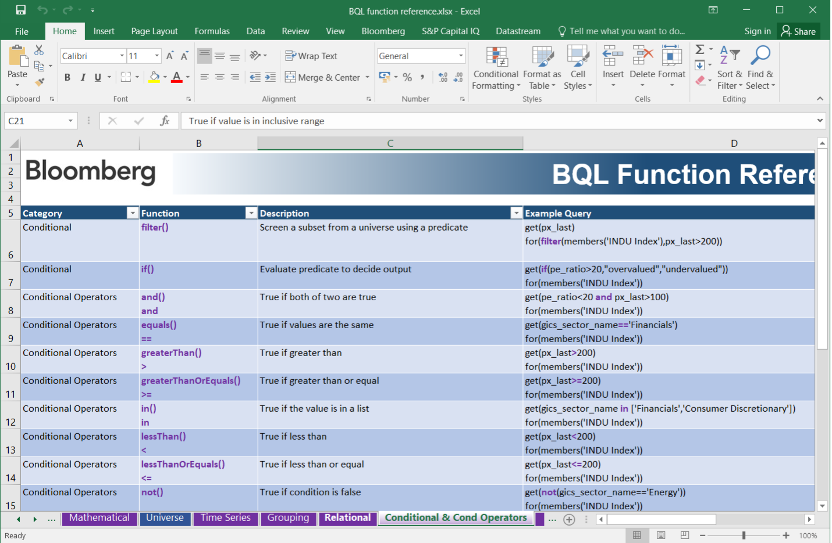

Figure 43: BQL Reference Excel Files

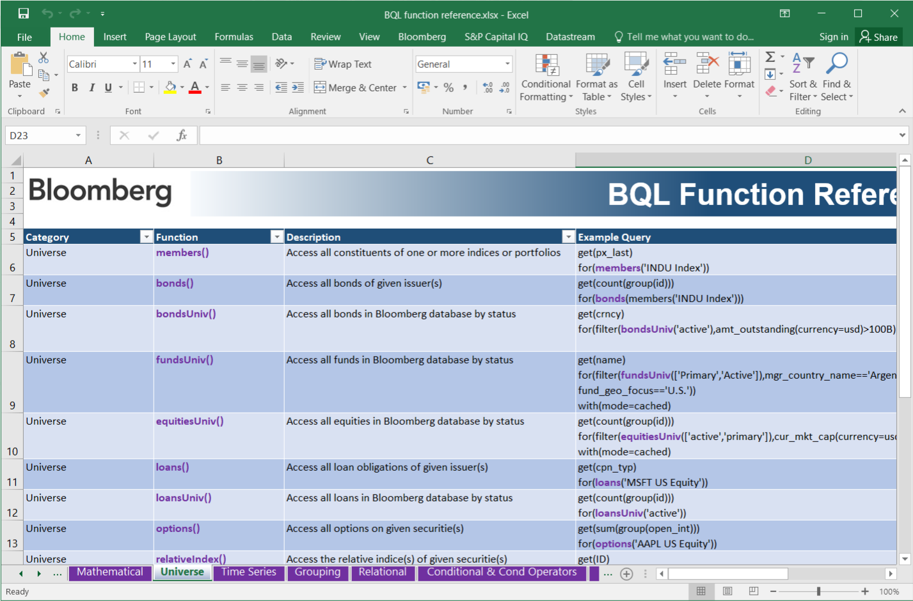

Figure 44: BQL Reference Excel Files

# Section 6: Case studies

In this section we will cover some common tasks that could potentially be carried out by interns/working students or fulltime members at the FI PD team. Make sure you can follow these quick examples by yourself.

## Getting Volume Data for Future Products

To start such a task we would recommend to follow a certain structure like here presented in the sceen shot. By structure we mean the excel file structure with a little table at the top of the sheet that presents the key variables used to retrieve data, so everybody can directly see what tickers were used, what products are concerned and what data fields are used. This will increase transparency, understandability and reduce errors in the making.

The Bloomberg-Tickers can be looked up on the website or in the Products excel file sorted by category (Dont forget: Bloomberg treats Futures as „Commodities“ so add the „Comdty“ to get the correct BL-Ticker).

Step 1) Setting up the file and structure

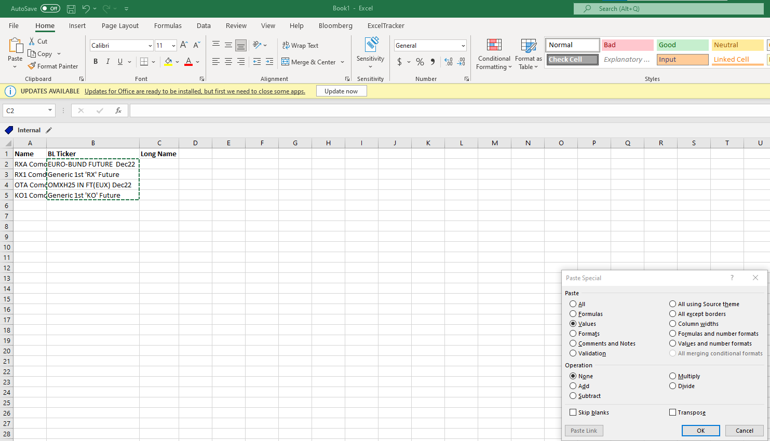

Figure 45: Spreadsheet Builder – Example

You can see that we used a formula like =BDP(A2,”NAME”) in the cell B2 to get the Name of the security. Now we have the data displayed but once we log off the termoinal in the background the displayed data will disappear after a certain time till you again log on and hit the refresh button so we copy the values over the formulas so that we will always be able to see the names later on.

Step 2) Set up the descriptive table

To the little descriptive table we can add columns like „Data Field“ and maybe „Field Description“ so everybody directly sees what is going on in the file as the data field arguments aren’t always self explanatory.

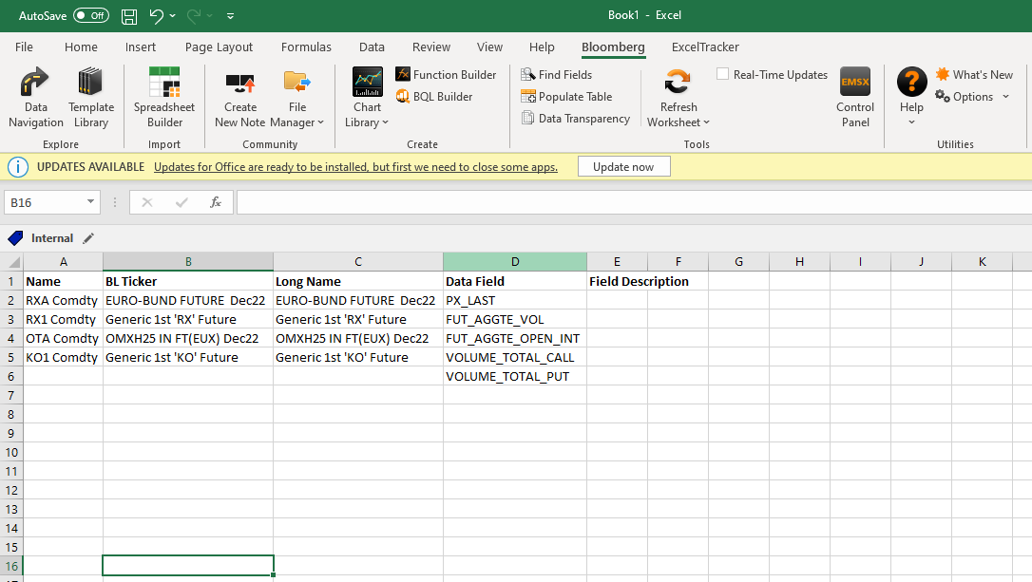

Figure 46: Spreadsheet Builder – Example

Step 3) Load the data by using the Spreadsheet Builder

As we now have everything we need to retrieve data, we can select the „Bloomberg“ Ribbon in the excel sheet and start. We use the previously discussed Spreadsheet Builder as it is the most convenient and fastest way to get to our goal.

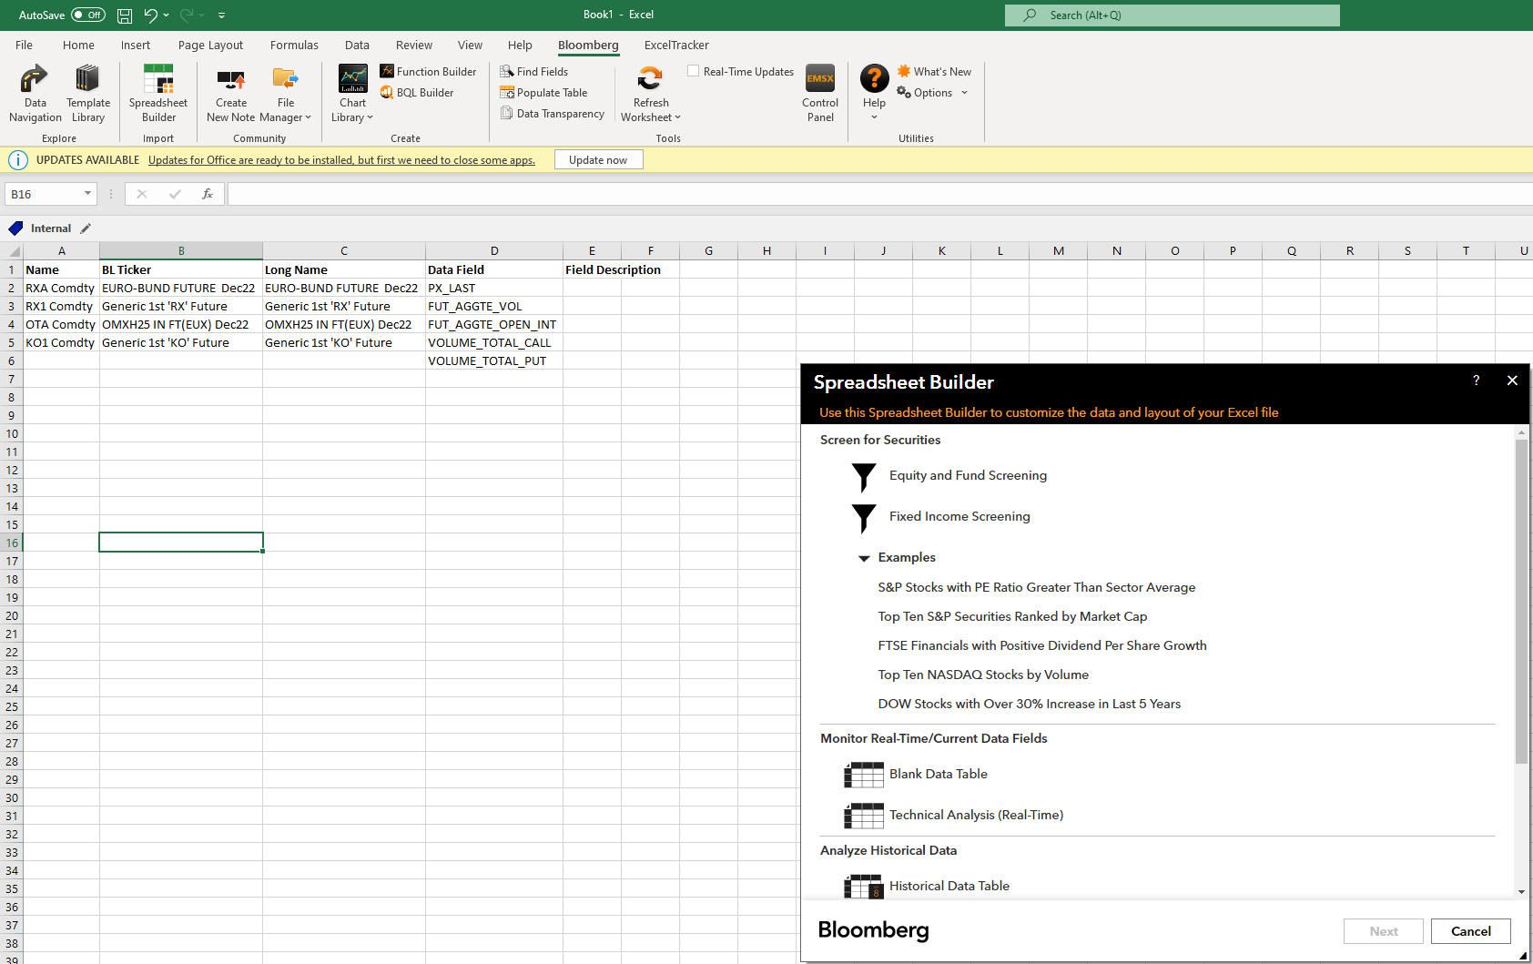

Figure 47: Spreadsheet Builder – Example

Step 4) Follow the instructions

Now we have to provide the Tickers. Click on the little button and select all rows that house the tickers for a quick action so that you don’t end up typing in everything one by one.

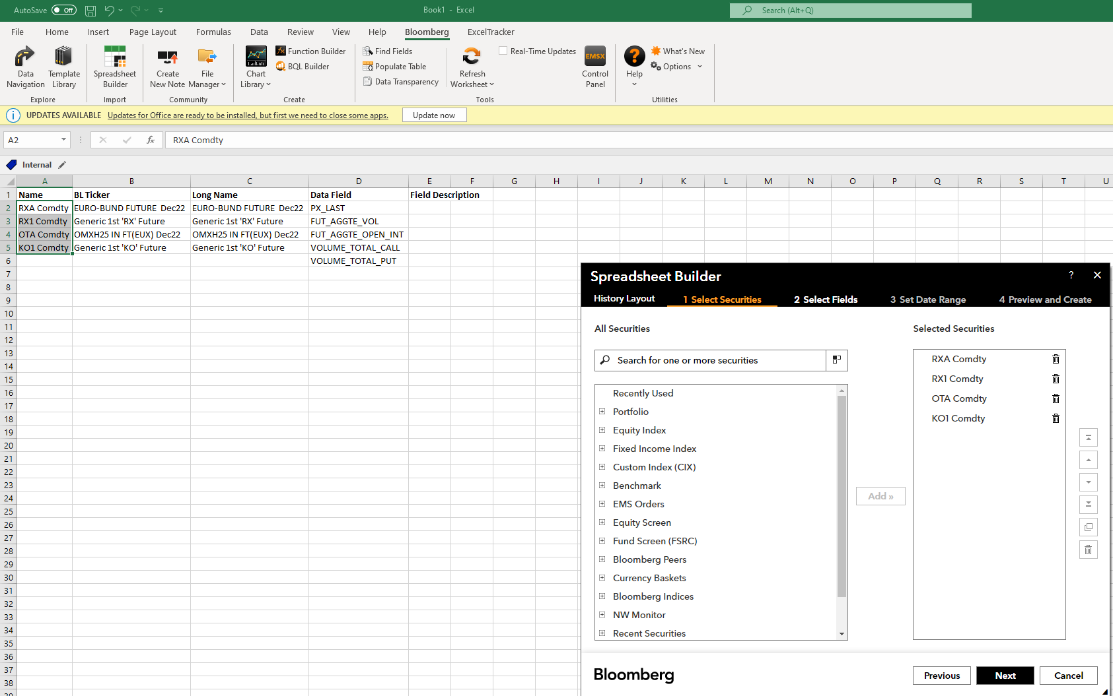

Figure 48: Spreadsheet Builder – Example

Step 5) Follow the instructions

Then you have to unfortunately type in the fields in manually. Type some keywords and select the correct fields.

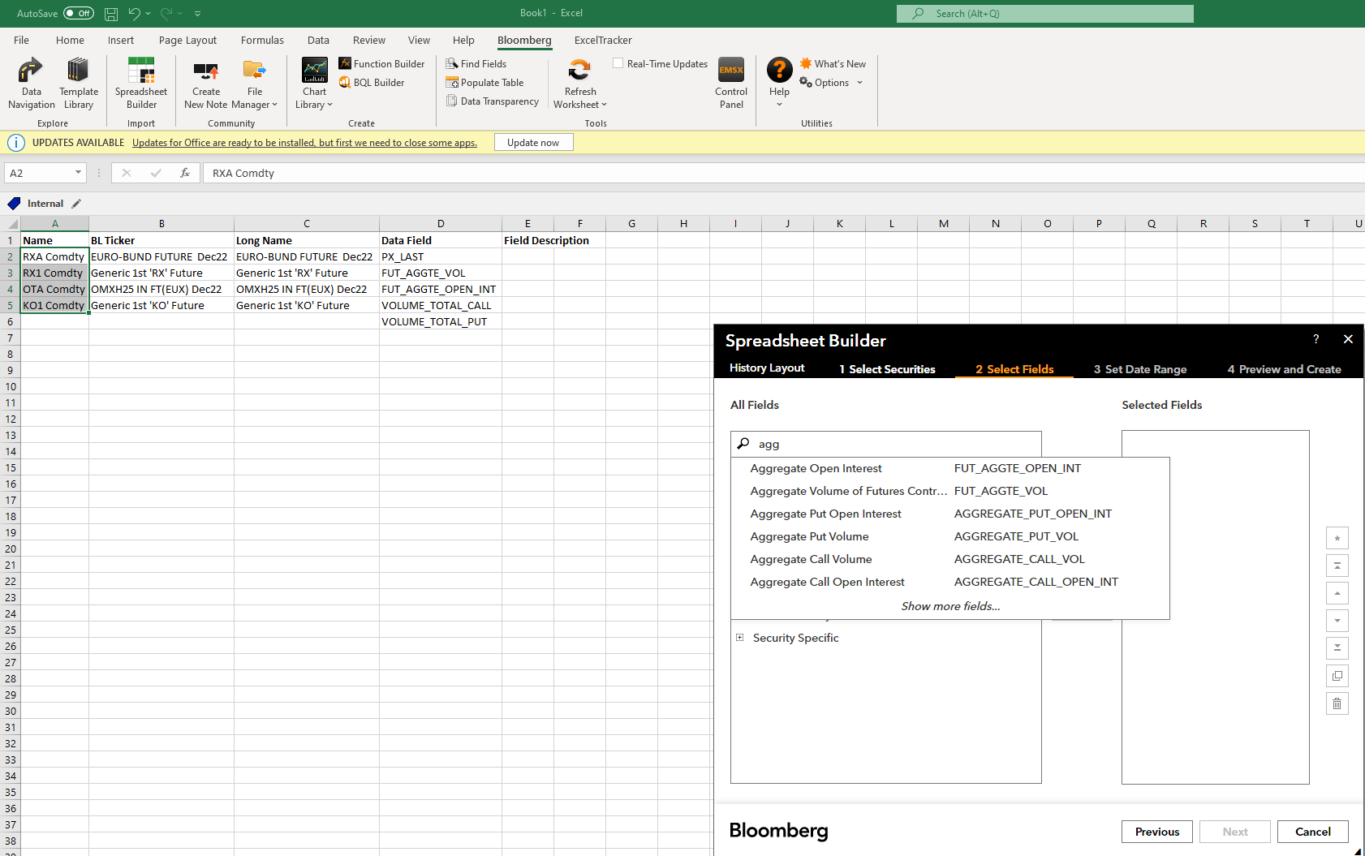

Figure 49: Spreadsheet Builder – Example

Step 6) Follow the instructions

Now there comes an important step: you can choose the timeframe for the data and the frequency. This can save you a lot of time e.g. retrieving monthly data directly and not having to mess with formulas in excel to get a monthly frequency out of daily data. You can always change the frequency afterwards to adapt to new requirements as we already saw in the function builder section.

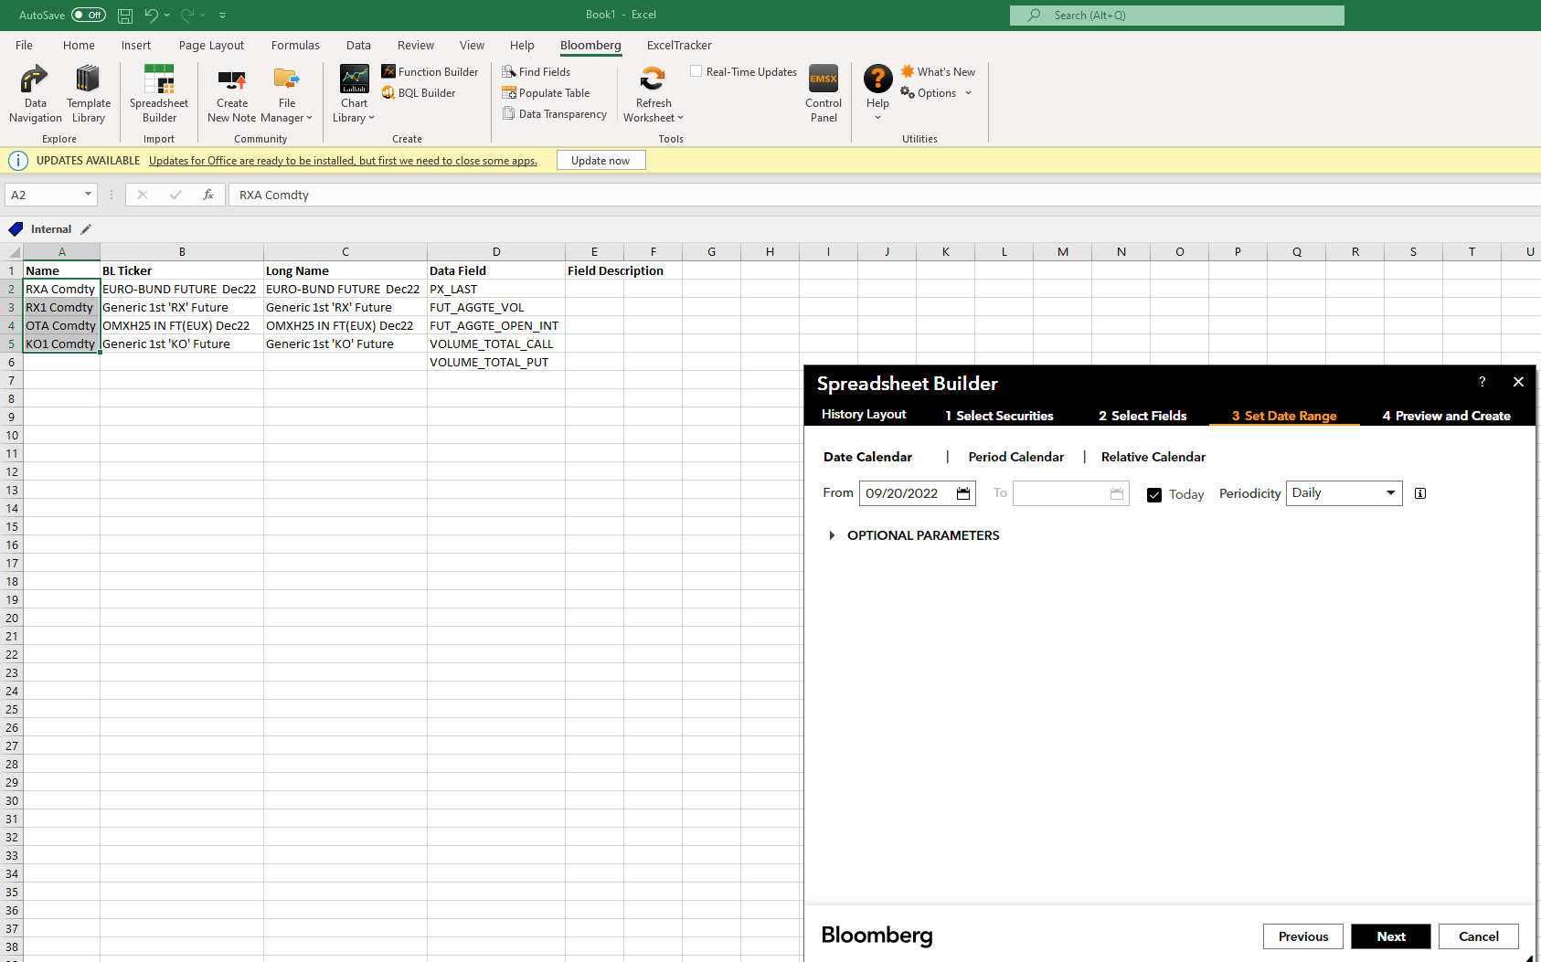

Figure 50: Spreadsheet Builder – Example

Step 7) Follow the instructions

Finally it asks you where to put the data. Again click on the little icon to set the position, the other parameters can be left on their default settings.

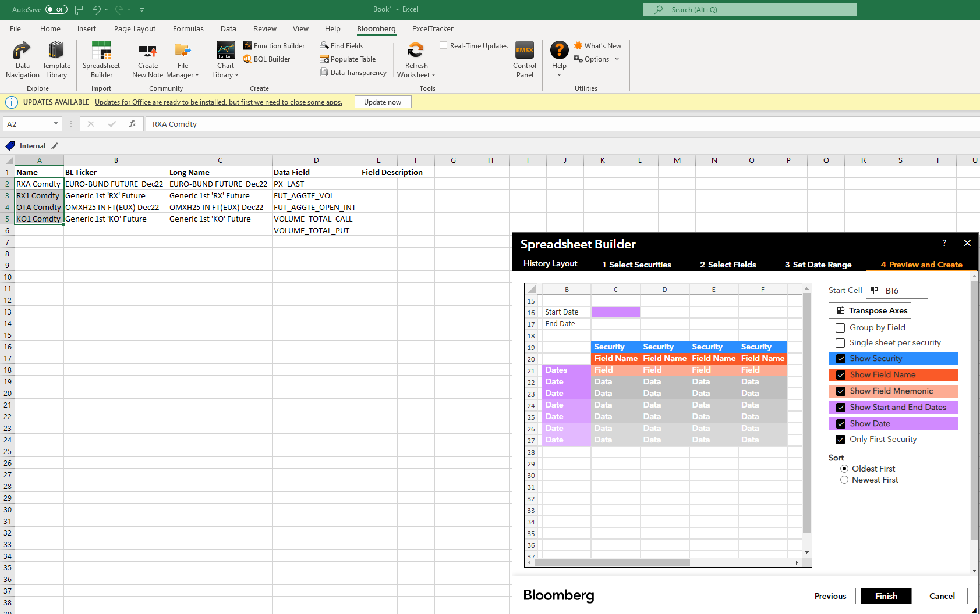

Figure 51: Spreadsheet Builder – Example

The result should look similar to the screenshot below:

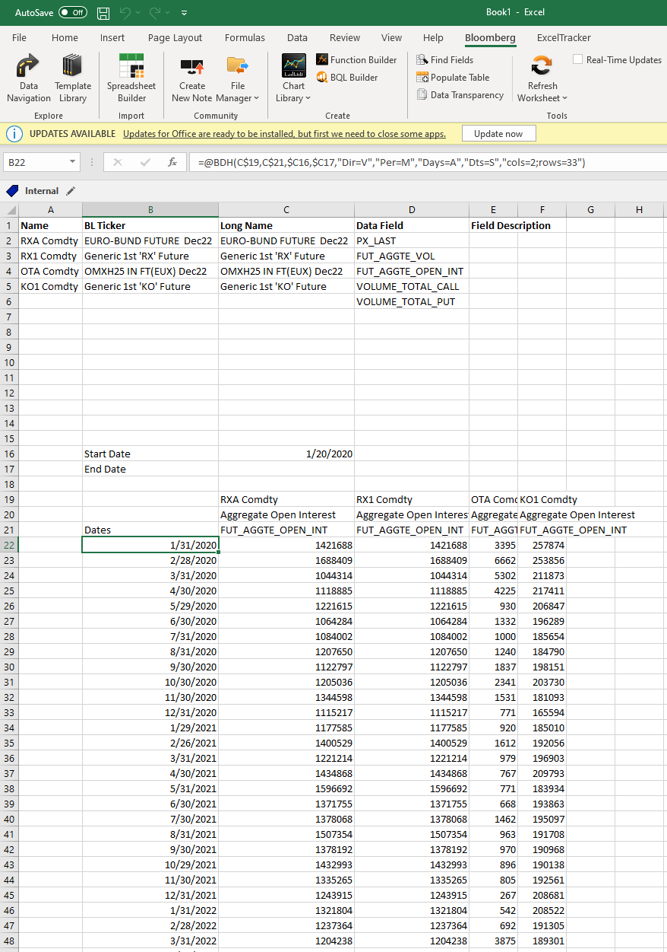

Figure 52: Spreadsheet Builder – Example

## Getting Volume Data for Options (on Futures)

If you are asked to provide Open Interest or Volume data for options (on Futures) you have to watch out as there aren’t Options on every futures product. After you have gone through all the exact same steps as before, you have to watch out at the step when choosing the data fields: here we have to apply a different method. For options the total volume is the sum of the Call and Put Volume, the same holds for the Open Interest, so we have double the data fields than we had for only future products.

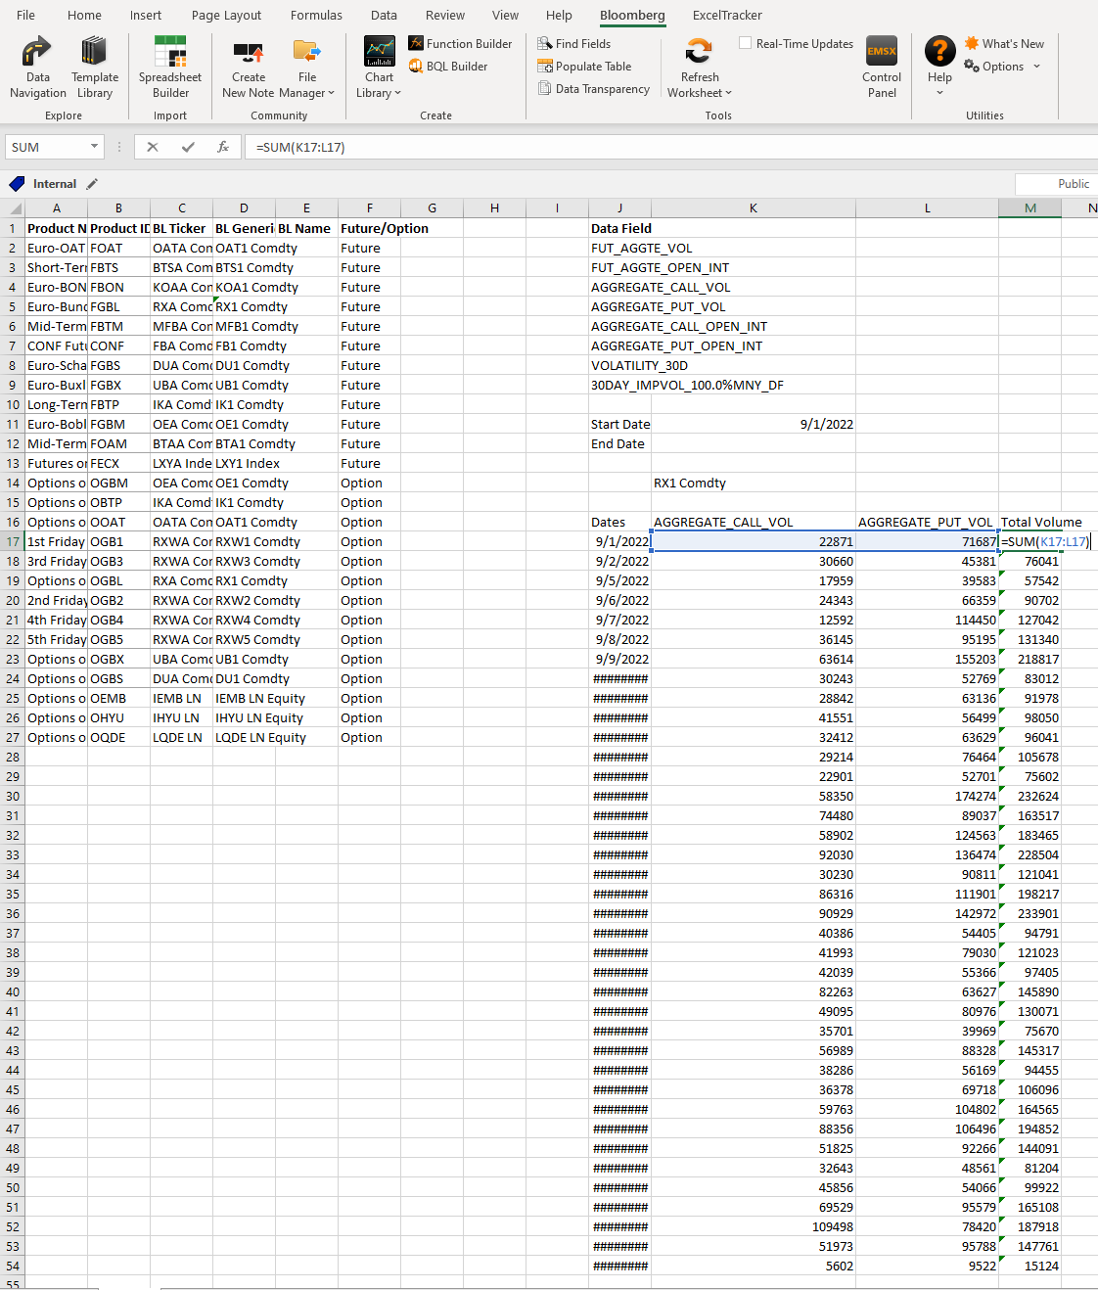

Figure 53: Result of retrieving volume data for Options on Futures

One can see, this time we want Options data for Options on the Euro-Bund Future. We took the fields **AGGREGATE_CALL_VOL** and **AGGREGATE_PUT_VOL** and finally summed them up in the sheet to arrive at the total volume we could display in a graph.

## Getting Open Interest Data for Future Products

We just simply repeat all the already known steps in the spreadsheet builder and just use the data field: **“FUT_AGGTE_OPEN_INT”**. See the screenshot below for a result.

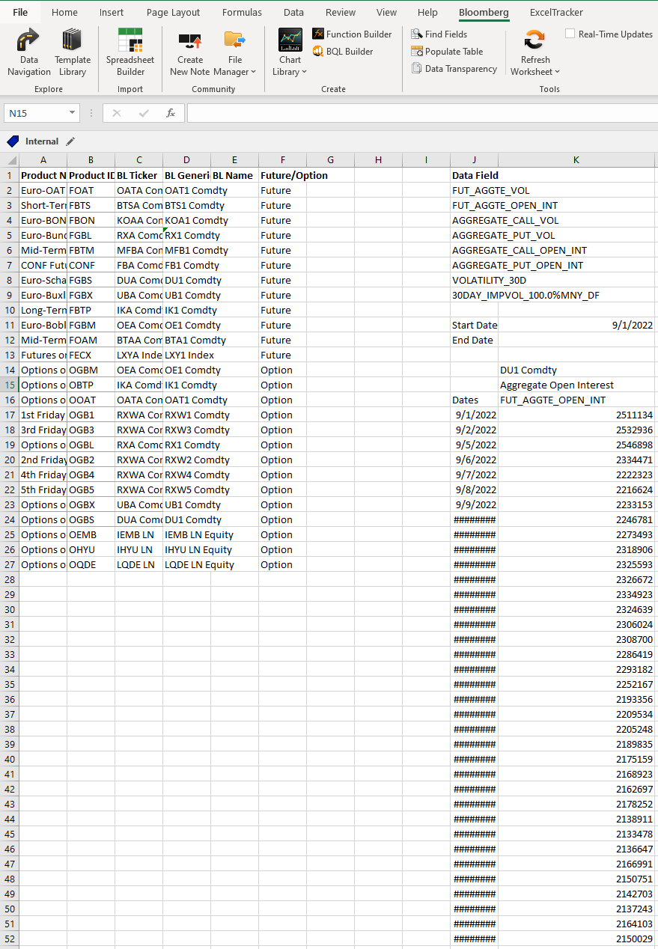

Figure 54: Result of retrieving volume data for Futures

## Getting Open Interest Data for Options (on Futures)

As we saw we have to choose for each product two data fields instead of only one for the future products. The same method will be applied here for the Open Interest where the total Open Interest is the sum of the Call and Put Open Interest.

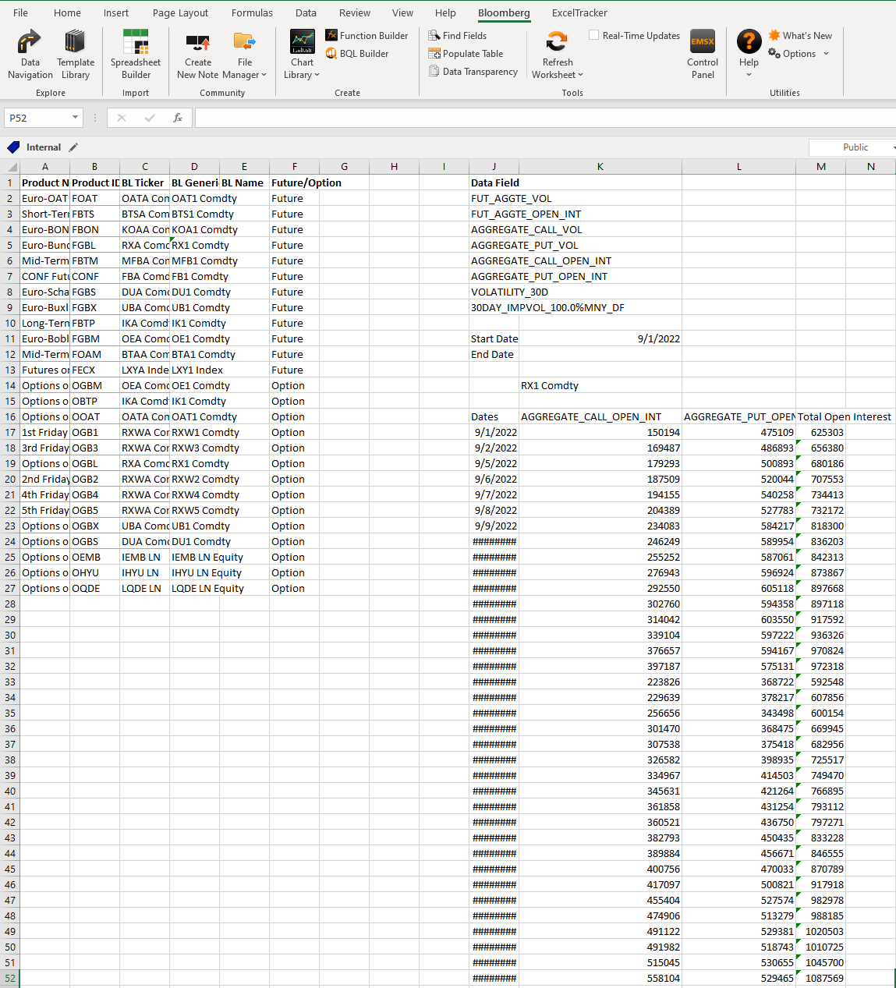

Figure 55: Result of retrieving open interest data for Options on Futures

## Getting Volatility Data for Future Products

When implied volatility for graphs is needed, we usually use the 100% Moneyness 30 day implied volatility but other Moneyness levels or day frames can be possible too, if in doubt ask what variant should be used.

We will set up the excel sheet as always and use again the **FLDS** function to search for the exact name of the volatility data field.

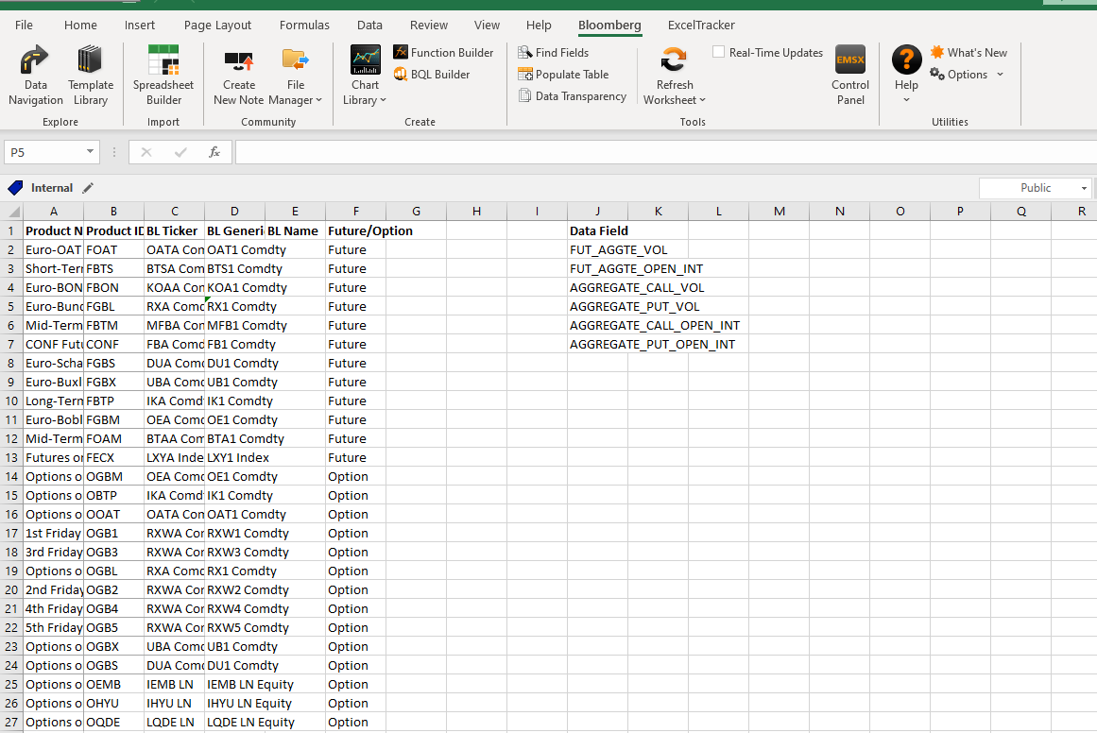

Figure 56: Excel File structure

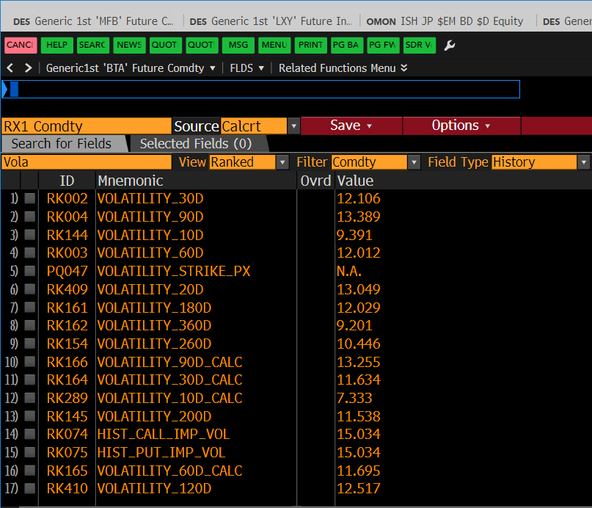

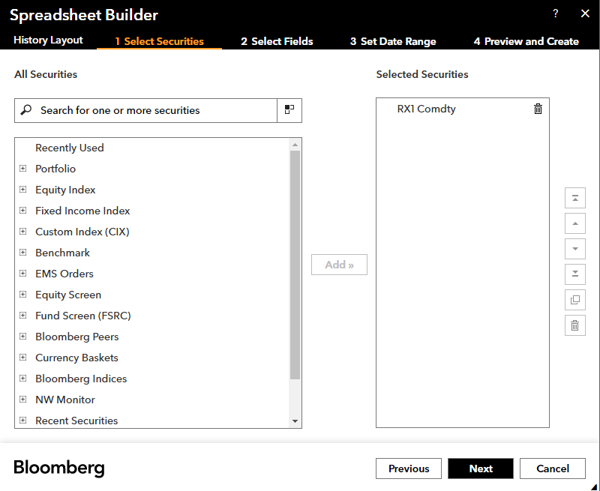

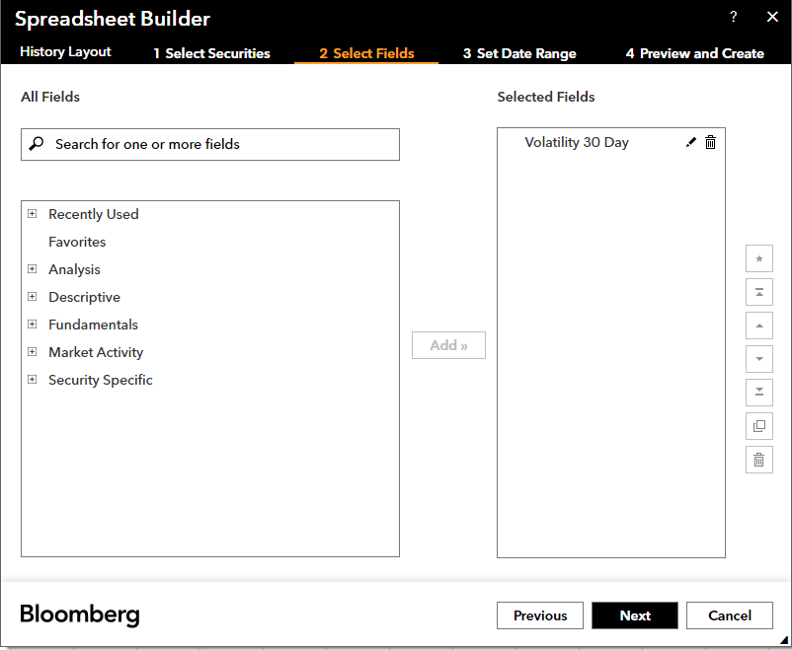

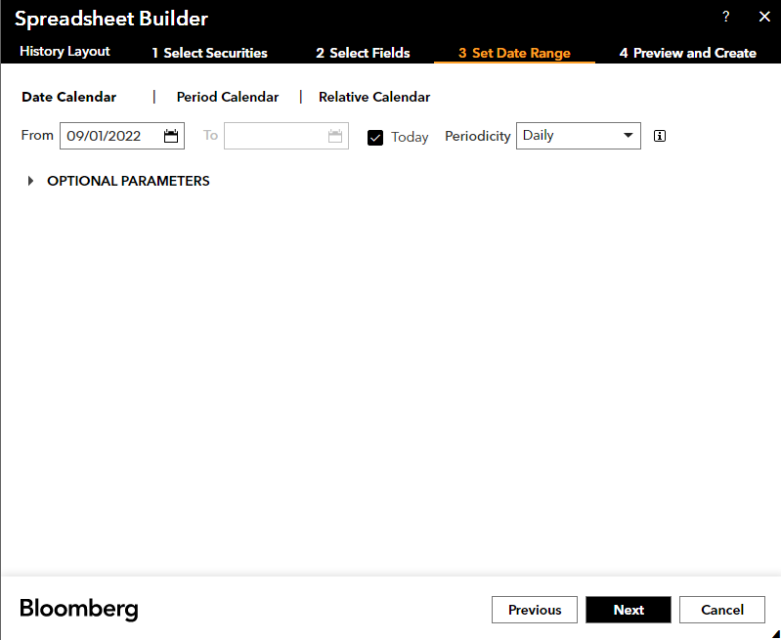

The results should look like the screenshot.

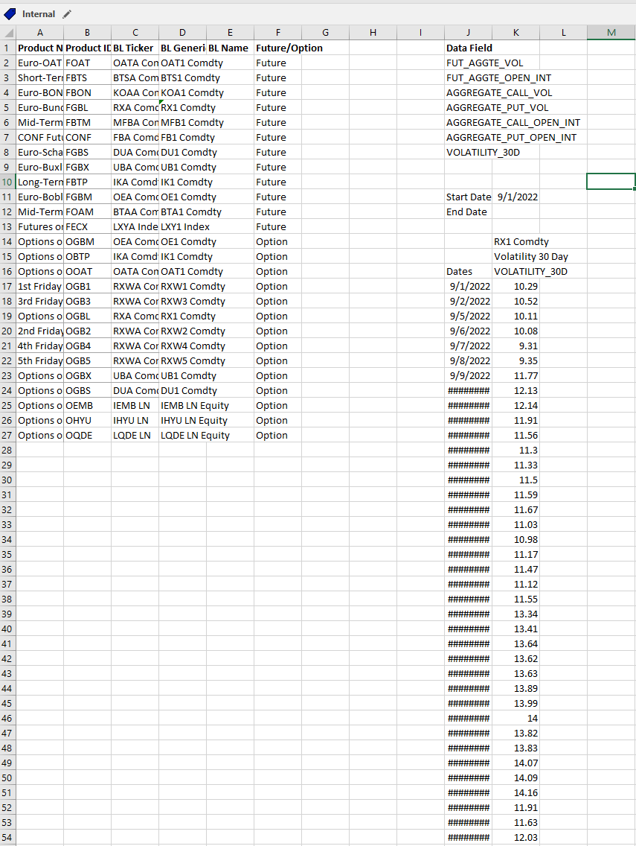

## Getting Implied Volatility Data for Options (on Futures)

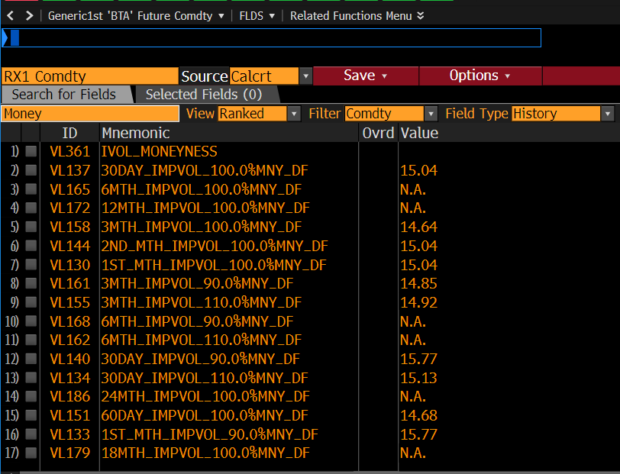

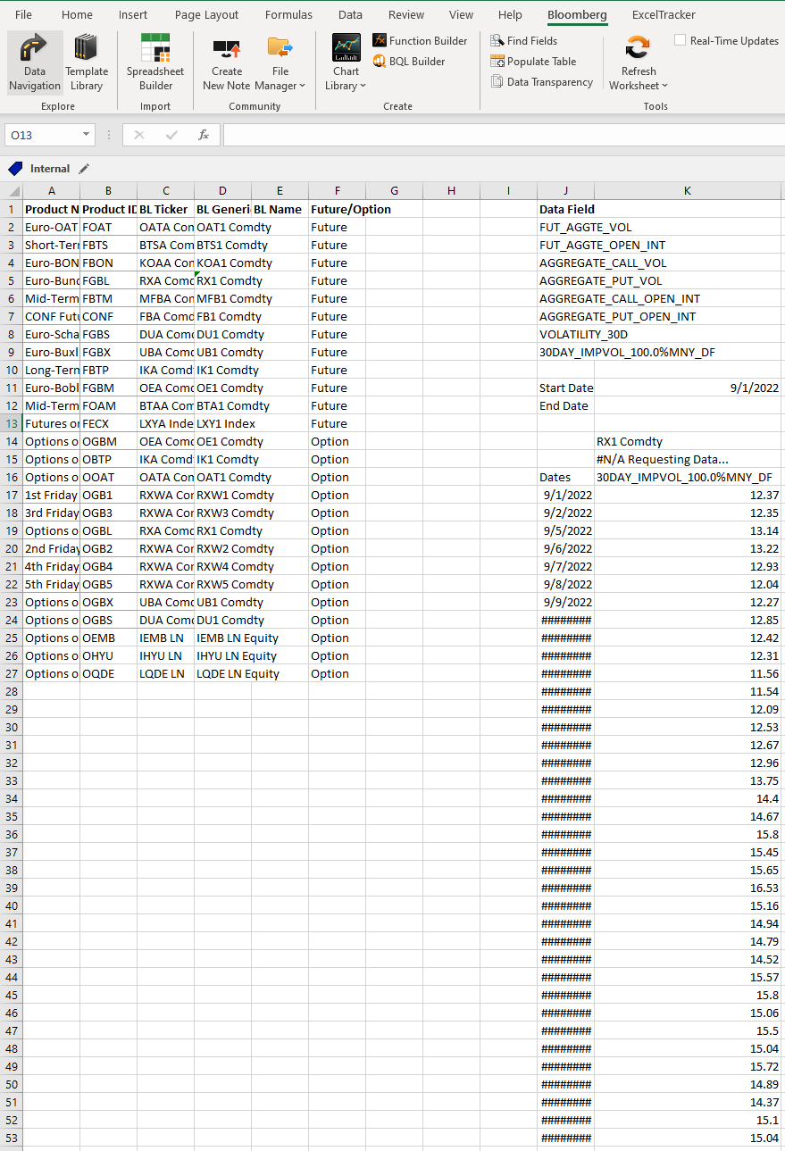

## Search for competitor products from other exchanges and get their data

If one is asked to provide data for unknown securities from, for example competing exchanges, the **SECF (Security Finder)** is the optimal starting point to choose. With that function we can obtain the needed BL-Tickers as the data fields for the tickers won’t change that much.

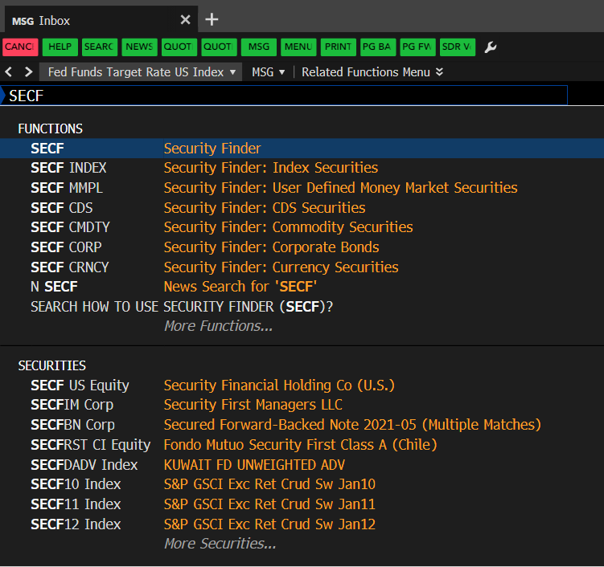

Figure 53: Go to the Security Finder

From here you should apply filtering criteria (name keywords, security type, exchange,etc.) to narrow the results.

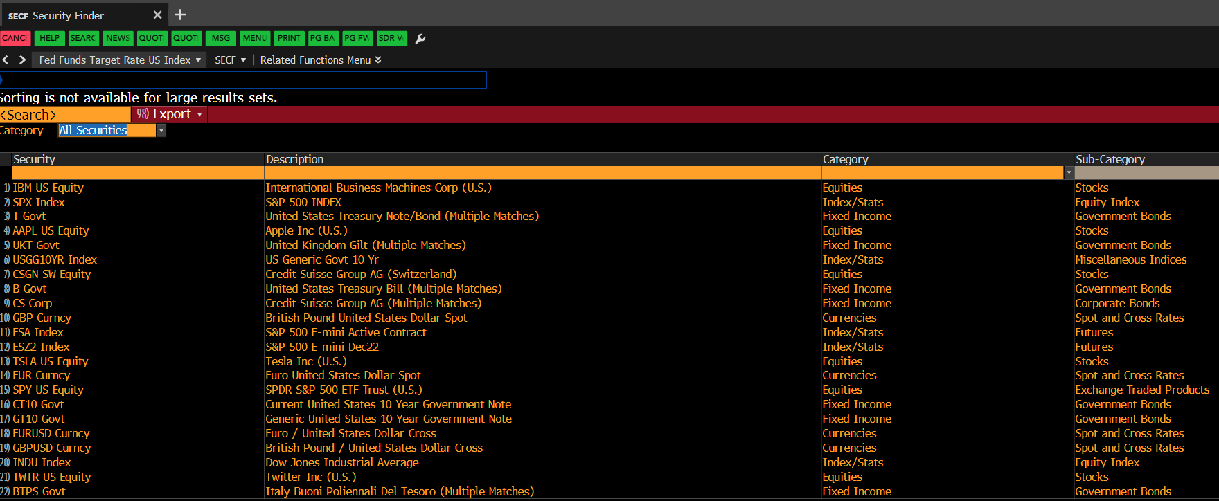

Figure 54: SECF Overview 1

If we wanted to find EUREX Fixed Income Futures products we can set the security type to Fixed Income, go to the Futures Ribbon and select in the Source column the abbreviation for the EUREX: EUX so that we only get products traded there. Finally we end up with a view like that:

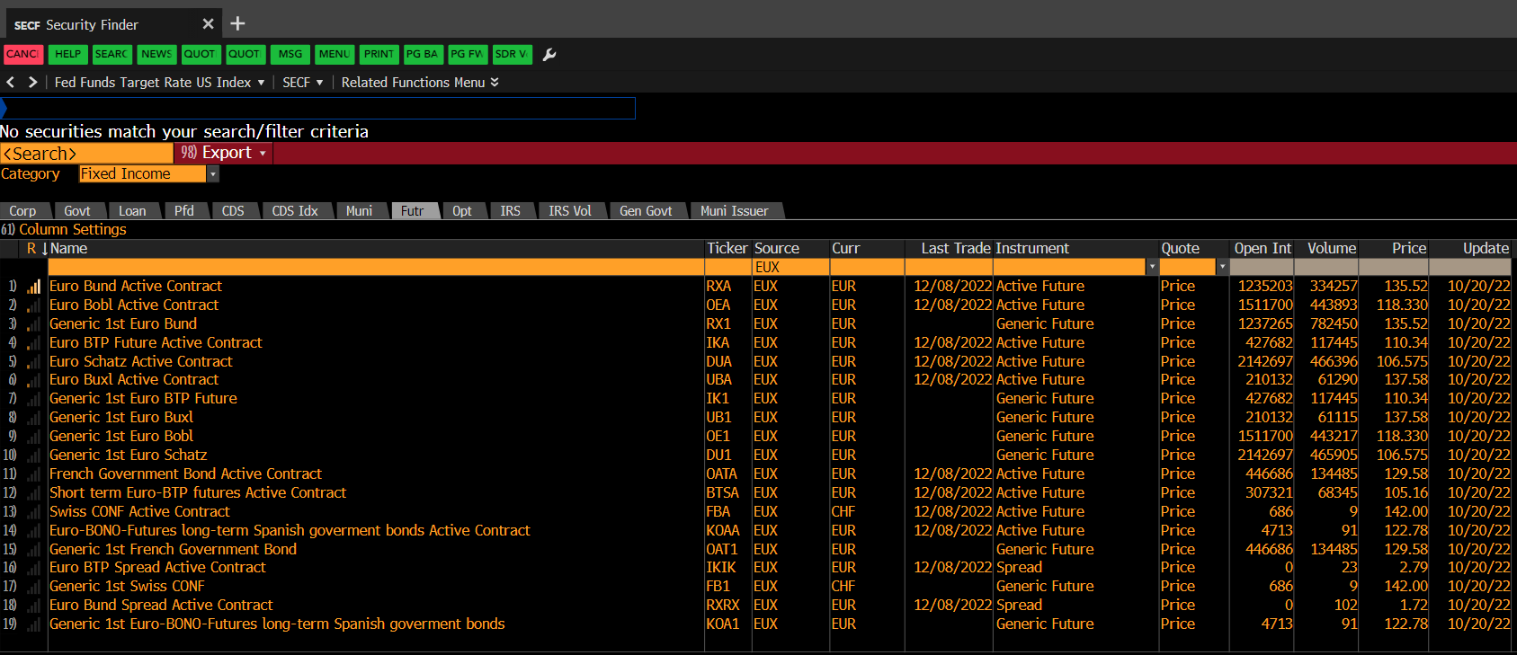

Figure 55: SECF Overview 2

We see that we found again the active contracts (“RXA”) and also some Generics that show up. Now lets say we want the Bloomberg-Tickers of the first 10 results (the column “Ticker”). Instead of having to type in every ticker by hand manually we can just use the lasso selection Bloomberg provides: Just right-click and hold the mouse button and select with quadratic lasso the area you want to copy, open an excel sheet and hit STR + V to paste the selected area. You maybe have to adjust the sleeted area a bit and repeat this process several times as the function works not always properly.

If we wanted to extract only the Generics, we could just filter by keyword:

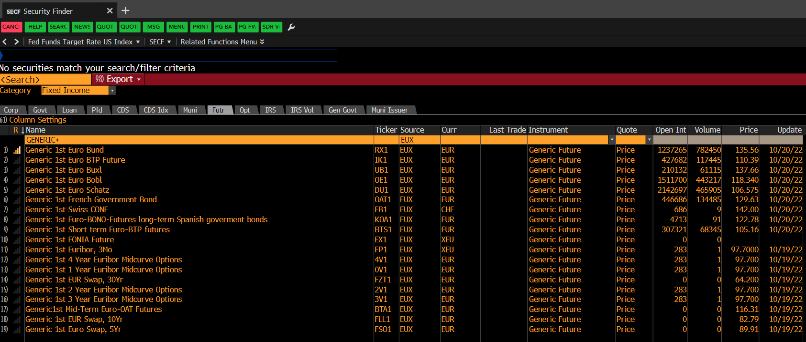

Figure 56: SECF Overview 3

# Section 7: BMC – Bloomberg Market Concepts

If you are completely new to the terminal and have already worked through this guide you can also consider doing the BMC later on, but only if there is appropriate time for that and no other projects will be left behind as the certificate is absolutely not mandatory and quite time consuming. So only pursue on taking the provided video courses if there is room for that, as there will be the basic concepts of economics covered that cant be skipped and therefore can be elusive for people familiar with basic principles of the economy.

BMC is an 8-hour, self-paced e-learning course that provides a visual introduction to the financial markets and covers more than 70 Terminal functions. BMC consists of four modules — Economics, Currencies, Fixed Income and Equities — woven together from Bloomberg data, news, analytics and television. By taking BMC, learners familiarize themselves with the industry-standard service through four heavily interconnected modules.

By taking BMC, you will:

**Learn the language of finance**

• Supplement your university learnings with practical knowledge of the markets.

• Familiarize yourself with more than 70 Bloomberg Terminal functions.

**Discover the inner workings of the markets**

• Learn what moves markets.

• Familiarize yourself with key benchmarks that professionals monitor.

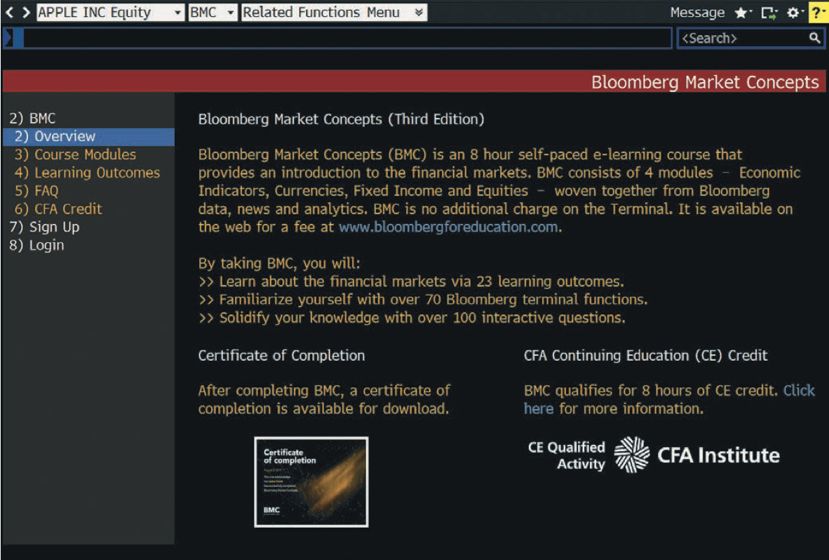

Figure 57: Bloomberg Market Concepts Certificates Landing Page

# Section 8: Getting help

If one runs into any problems or questions while working with the terminal or specific data points, don’t hesitate to reach out to the helpdesk, by just hitting the help button twice to speak via chat directly to the Bloomberg service**. You are advised to use this service heavily to get the tasks done quickly.**

Enter HELP <GO> for an online user guide to the overall logic and navigation of the Bloomberg Terminal.

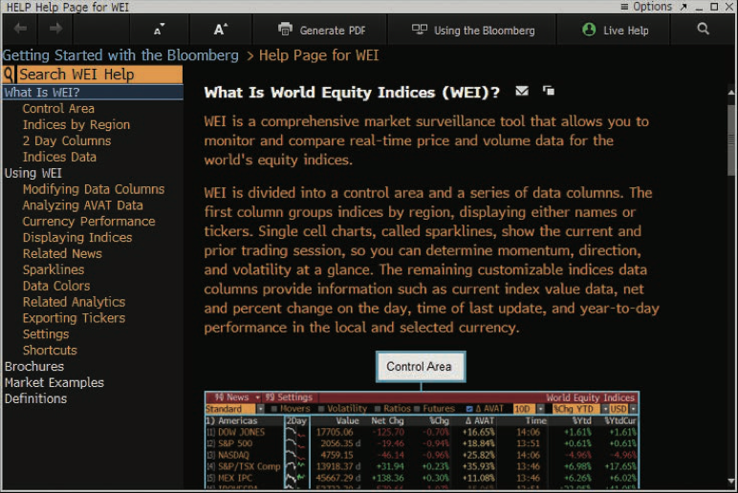

Figure 58: Bloomberg Help Functions

Enter BPS <GO> for the Bloomberg Terminal Resource Center homepage with links to training resources, including training documents and video tutorials.

Each function has a comprehensive, searchable online user guide designed to answer common questions and describe key functionality. From within any function, press <HELP> once to access that function’s Help Page.

To ask any Bloomberg-related questions, students can start an Email communication with the Bloomberg Help Desk. Press <HELP> twice to connect.

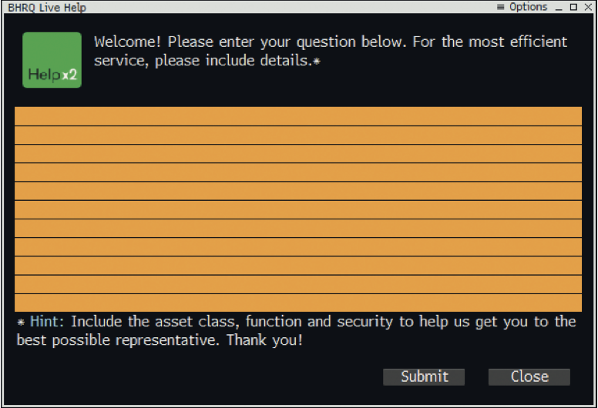

Figure 59: Bloomberg Help Text Chat